**School Management System**

**Al-Azhar Public School Madyan Swat**

**(Semester Project in Visual Programming Subect)**

**BY**

Akhtar Zeb Bacha

**Bachelor of Science in Computer Science**

**Department of Computer Science**

**Government Collge Madyan**

**Swat, Pakistan**

**December, 2024**

Contents

[Chapter 1 1](#_Toc189771460)

[1 Introduction 1](#_Toc189771461)

[1.1 Background 2](#_Toc189771462)

[1.2 Motivation 2](#_Toc189771463)

[1.3 Problem Statement 3](#_Toc189771464)

[1.4 Problem Solution 3](#_Toc189771465)

[1.5 Scope and Objective 4](#_Toc189771466)

[1.5.1 Objective 4](#_Toc189771467)

[1.5.2 Scope 4](#_Toc189771468)

[1.6 Tools and Techniques 5](#_Toc189771469)

[1.6.1 Microsoft SQL Server 5](#_Toc189771470)

[1.6.2 Microsoft Visual Studio 5](#_Toc189771471)

[1.6.3 GSM 5](#_Toc189771472)

[1.7 Thesis Outline 5](#_Toc189771473)

[Chapter 2 7](#_Toc189771474)

[2 Software Project Planning 7](#_Toc189771475)

[2.1 Introduction 7](#_Toc189771476)

[2.2 Project/Product Feasibility Report 7](#_Toc189771477)

[2.2.1 Technical Feasibility 8](#_Toc189771478)

[2.2.2 Operational Feasibility 8](#_Toc189771479)

[2.2.3 Schedule Feasibility 8](#_Toc189771480)

[2.2.4 Specification Feasibility 8](#_Toc189771481)

[2.2.5 Legal & Ethical Feasibility 8](#_Toc189771482)

[2.3 Project Scope 9](#_Toc189771483)

[2.4 Project Characteristics 9](#_Toc189771484)

[2.5 Products and Activities 9](#_Toc189771485)

[2.6 Activities Estimation 10](#_Toc189771486)

[2.7 Scheduling 12](#_Toc189771487)

[2.8 Risk Management 12](#_Toc189771488)

[Chapter 3 15](#_Toc189771489)

[3 System Requirements 15](#_Toc189771490)

[3.1 User Requirements 15](#_Toc189771491)

[3.2 Functional Requirements 16](#_Toc189771492)

[3.2.1 Conversations Registration 16](#_Toc189771493)

[3.2.2 Conversations Profile 17](#_Toc189771494)

[3.2.3 Conversations Profile Upload 18](#_Toc189771495)

[3.2.4 Conversation Accessible information. 18](#_Toc189771496)

[3.2.5 Conversations User Notification 19](#_Toc189771497)

[3.2.6 Conversation Marks Grading 20](#_Toc189771498)

[3.2.7 Conversations generate transcript. 21](#_Toc189771499)

[3.2.8 Conversations Tax 21](#_Toc189771500)

[3.2.9 Bills 22](#_Toc189771501)

[3.2.10 Email Notification. 23](#_Toc189771502)

[3.3Non-functional Requirements 24](#_Toc189771503)

[3.3.1 Performance Requirements 24](#_Toc189771504)

[3.4 User Documentation 25](#_Toc189771505)

[3.5Assumptions and Dependencies 25](#_Toc189771506)

[3.6 Overall System Description 25](#_Toc189771507)

[3.6.1 User characteristics 25](#_Toc189771508)

[3.6.2 Operating environment 26](#_Toc189771509)

[3.7.1 Software constraints 26](#_Toc189771510)

[3.7.2 Hardware constraints 26](#_Toc189771511)

[3.7.3 Cultural constraints. 26](#_Toc189771512)

[3.7.4 Legal constraints 26](#_Toc189771513)

[3.7.5 Environmental constraints 26](#_Toc189771514)

[3.7.6 User constraints 26](#_Toc189771515)

[3.8 External Interface Requirements 27](#_Toc189771516)

[3.8.1 Hardware Interfaces 27](#_Toc189771517)

[3.8.2 Software Interfaces 27](#_Toc189771518)

[Chapter 4 28](#_Toc189771519)

[4 System Design 28](#_Toc189771520)

[4.1 Use case diagram 28](#_Toc189771521)

[4.2 Activity Diagram 29](#_Toc189771522)

[4.2.1 Activity diagram for user login 29](#_Toc189771523)

[4.2.2 Activity diagram for user Registration 30](#_Toc189771524)

[4.2.3 Activity diagram Admin Login 31](#_Toc189771525)

[4.2.4 SMS activity diagram 32](#_Toc189771526)

[4.3 Sequence Diagram 33](#_Toc189771527)

[4.3.1 Sequence Diagram for student Registration 33](#_Toc189771528)

[4.3.2 Recording attendance Sequence Diagram 34](#_Toc189771529)

[4.3.3 Attendance Sequence Diagram 34](#_Toc189771530)

[4.3.4 Sequence Diagram for viewing student status by the parent. 35](#_Toc189771531)

[4.4 Data Flow Diagram 37](#_Toc189771532)

[4.4.1 Data Flow Diagram level 0 37](#_Toc189771533)

[4.4.2 Data Flow Diagram level 1 38](#_Toc189771534)

[4.4.3 Data Flow Diagram level 2 40](#_Toc189771535)

[4.5 Entity Relationship Diagram 42](#_Toc189771536)

[4.6 User Interface 43](#_Toc189771537)

[Chapter 5 54](#_Toc189771538)

[5 System Testing 54](#_Toc189771539)

[5.1 Black Box Testing Of System 54](#_Toc189771540)

[5.1.1 User Registration 54](#_Toc189771541)

[5.1.2 Admin sign up 55](#_Toc189771542)

[5.1.3 Employee Registration / sign up 56](#_Toc189771543)

[5.1.4 User login 57](#_Toc189771544)

[5.1.5 Edit profile 58](#_Toc189771545)

[5.1.6 Bills 59](#_Toc189771546)

[5.1.7 Tax Option 59](#_Toc189771547)

[5.1.8 Trancript 60](#_Toc189771548)

[5.1.9 Email 61](#_Toc189771549)

[5.1.10 Database. 62](#_Toc189771550)

[5.1.11 Database Backup 63](#_Toc189771551)

[5.1.12 Yearly Tax report. 64](#_Toc189771552)

[5.1.13 Log out 65](#_Toc189771553)

[Chapter 6 67](#_Toc189771554)

[6 Conclusion 67](#_Toc189771555)

[Chapter 7 68](#_Toc189771556)

[7 References 68](#_Toc189771557)

**List of Tables**

[Table 1.1 Documentation Outline 6](#_Toc25343490)

[Table 2.1 Product and Activities 10](#_Toc25343491)

[Table 2.2 Activities Estimation 11](#_Toc25343492)

[Table 2.3 Activities Risk 13](#_Toc25343493)

[Table 3.1 User Requirements 15](#_Toc25343494)

[Table 3.2 Login and Registration Requirement 16](#_Toc25343495)

[Table 3.3 Profile Requirement 17](#_Toc25343496)

[Table 3.4 Profile upload 18](#_Toc25343497)

[Table 3.5 All users’ information. 19](#_Toc25343498)

[Table 3.6 User Notification 20](#_Toc25343499)

[Table 3.7 Marks Grading 21](#_Toc25343500)

[Table 3.8 generate transcript 22](#_Toc25343501)

[Table 3.9 TAX 23](#_Toc25343502)

[Table 3.10 Bills 23](#_Toc25343503)

[Table 3.11 Send Email 24](#_Toc25343504)

[Table 5.1 User Registration 53](#_Toc25343505)

[Table 5.2 Admin Sign up 55](#_Toc25343506)

[Table 5.3 Employee Registration (Workers) sign up 56](#_Toc25343507)

[Table 5.4 User Login 57](#_Toc25343508)

[Table 5.5 Edit profile 58](#_Toc25343509)

[Table 5.6 Bills Option 59](#_Toc25343510)

[Table 5.7 Tax Option 60](#_Toc25343511)

[Table 5.8 Trancript 61](#_Toc25343512)

[Table 5.9 Email 62](#_Toc25343513)

[Table 5.10 Database. 63](#_Toc25343514)

[Table 5.11 Database Backup. 64](#_Toc25343515)

[Table 5.12 Admin See The Taxes report on yearly 65](#_Toc25343516)

[Table 5.13 Log Out 66](#_Toc25343517)

**List of Figures**

[Figure 2.1: Gantt Chart 12](#_Toc25343464)

[Figure 4.1: Use Case Diagram 29](#_Toc25343465)

[Figure 4.2: Activity Diagram User Login 30](#_Toc25343466)

[Figure 4.3: Activity Diagram User Register 31](#_Toc25343467)

[Figure 4.4: Activity Diagram for Admin 32](#_Toc25343468)

[Figure 4.5: Activity Diagram for School Management system. 33](#_Toc25343469)

[Figure 4.6: Student Registration Sequence Diagram. 34](#_Toc25343470)

[Figure 4.7: Sequence Diagram for Recording Attendance. 35](#_Toc25343471)

Figure [4.3.3 Attendance Sequence Diagram 35](#_Toc25343472)

[Figure 4.8: Transcript Sequence Diagram 36](#_Toc25343473)

[Figure 4.9: Sequence Diagram for viewing student status by the parent. 37](#_Toc25343474)

[Figure 4.10: DFD Level 38](#_Toc25343475)

[Figure 4.11: DFD Level 1 40](#_Toc25343476)

[Figure 4.12: DFD Level 2 41](#_Toc25343477)

[Figure 4.13 Login Activity 42](#_Toc25343478)

[Figure 4.14 Main Screen Activity 43](#_Toc25343479)

[Figure 4.15 Student info Activity 44](#_Toc25343480)

[Figure 4.16 Employee Info Activity 45](#_Toc25343481)

[Figure 4.17 Add subject Activity 46](#_Toc25343482)

[Figure 4.18 Certificate Activity 47](#_Toc25343483)

[Figure 4.19 Add classes 48](#_Toc25343484)

[Figure 4.20 Program configuration Activity 49](#_Toc25343485)

[Figure 4.21 Tax Activity 50](#_Toc25343486)

[Figure 4.22 Transcript Activity 51](#_Toc25343487)

[Figure 4.23 Admin List Type Activity 52](#_Toc25343488)

[Figure 4.24 Notification and Email Activity 52](#_Toc25343489)

# 

# 1 Introduction

Now a day’s education plays a great role in development of any country. Many of education organizations try to increase education quality. One of the aspects of this improvement is managing of school resources.

School Management System carried on by any individual or institution engaged in providing a services to students, teachers, guardians and other persons are intermediary that performs one or more of the following functionalities Student Admission, Employee Registration, Student List, Employee List, Student Attendance, Employee Attendance, Student Routine, Result Management, Payroll & Accounts.

School Management System (SMS) is such a service which provides all services for an educational institute to make your life easier and faster by assuring its performance. Easy User Management System, Easy Admission Process, Easy Attendance System.

SMS is a system that will provide you a bird’s eye view of the functioning of the entire educational institution. It is a management information system helps to manage the different processes in an educational institution like General Administration, Staff Management, Academics, Student Management, and Accounts etc. The information is made using the latest technologies and help’s to make decision making a lot faster, effective and easier than ever before. Also helps to improve the overall quality of education of the institution.

We use database and database technology are having a major impact on the growing use of computers. The implementation of the system was done using c# and SQL Server 2012 technologies, allowing system to be run in Windows OS.

In a nutshell, Education Management Software managed your education institution by simplifying and automating processes and addressing the needs of all stake holders helping them to be more efficient in their respective roles.

## 1.1 Background

Education system forms the backbone of every nation. And hence it is important to provide a strong educational foundation to the young generation to ensure the development of open-minded global citizens securing the future for everyone. Advanced technology available today can play a crucial role in streamlining education-related processes to promote solidarity among students, teachers, parents and the school staff.

Education is central to development. It is one of the most powerful instruments for reducing poverty and inequality and lays a foundation for sustained economic growth. With this aim currently our government has given special emphasis to the educational sector and school improvement activities such as continuous professional development for teachers, training and upgrading teachers and capacitating schools with manpower and materials are among the major actions which have been taken in both primary and secondary schools. In order to facilitate and simplify these actions one of the major tool is to have automated school management system. School Management System(SMS) consists of tasks such as registering students, attendance record keeping to control absentees, producing report cards, producing official transcript, preparing timetable and producing different reports for teachers, parents, officials from Dawn cambridge high school and other stakeholders. Automation is the utilization of technology to replace human with a machine that can perform more quickly and more continuously [2]. By automating SMS documents that took up many large storage rooms can be stored on few disks. Transcript images can be annotated. It reduces the time to retrieve old transcripts from hours to seconds. However, the school system in the government schools of Dawn cambridge high school is not automated and the record officers generate transcripts and reports manually and the school administrators use their experienced knowledge of miss and hit approaches to prepare time tables.

## 1.2 Motivation

There thousands of schools available to train and educate students for their practical life. And we can clearly see differences in schools management .school management employees etc are tired to make every report on daily bases manually however to much pages and time and resources waste because of this manual system. So we wanted to give users best experience using new technology to automate this whole work by using centralized database. So school management team will take benefits from it like students, teachers, accountants, administration and principle .

## 1.3 Problem Statement

To help promote students achievement and success, schools must have access to complete accurate, and timely information about students. One of the benefits of automated SMS is that the student record system will simplify retrieval of required information and is a great instrument for school improvement by taking measures from the information acquired.

1. Teachers may want to associate a student with his parent or emergency persons for disciplinary measures which need searching of the students record in the record office. It has been difficult to search a record from thousands of such records and observed that students can take any person claiming that he/she is their parent or emergency person which creates problem in control of students.
2. Due to the inefficiency of the current manual system, the need arises to automate SMS in order to efficiently handle students’ attendance, to produce transcript, report cards and the various reports satisfying users and customers and to produce timetable which can schedule courses for teachers and classes of students

## 1.4 Problem Solution

To handle such problem as discussed above we built an web based software that will work online as well offline it is an automated system that will be able to save all the information of school. And it will provide ease to staff and administration department, account department and class room teachers to find any record easily by just clicking and entering Id.

1. Admission department will be able to easily put new student data along with his registration number and his all record which needed like name, father name , guardian , cell no , class in which he want to take admission and all which is needed we have put all the variable and it will be stored in database using different queries.

2. Through this software school management office can easily put all the teacher record new teachers’ record as well present teacher in school and it will be stored in database using different queries.

3. Parents will be notified through sms notification because GSM module is used to send messages to the parents and guardians. They will be able to notify about their children fee and result or any announcement.

4. All the expenses of the school like bills and everything like Goods which is needed for the school data will be put and store in data base by which we can be able to know school expenses monthly and on yearly base.

## 1.5 Scope and Objective

### 1.5.1 Objective

As per discussion with the client, the current user requirements are highlighted below.

* Managing Fee records
* Managing Staff salaries
* Managing Utility Bills
* Managing Full records
* Managing Exams
* Managing School schedules
* Managing Alert systems
* Advertisements
* Certificates allocation

## 1.5.2 Scope

The different area where we can use this application as:

* Any education institution makes use of it.
* It can be used in offices and modifications can be easily done according to requirements

## 1.6 Tools and Techniques

Following tools & technologies will be used for developing this application.

### 1.6.1 Microsoft SQL Server

Microsoft SQL Server is a relational database management system developed by Microsoft. As a database server, it is a software product with the primary function of storing and retrieving data as requested by other software applications—which may run either on the same computer or on another computer across a network.

### 1.6.2 Microsoft Visual Studio

Microsoft Visual Studio is an integrated development environment from Microsoft. It is used to develop computer programs, as well as websites, web apps, web services and mobile apps.

### 1.6.3 ****GSM****

**GSM (Global System for Mobile Communications, originally Groupe Spécial Mobile)**, is a standard developed by the European Telecommunications Standards Institute ([ETSI](https://en.wikipedia.org/wiki/ETSI" \t "_blank)).

It was created to describe the protocols for second-generation ([2G](https://electronicsforu.com/videos-slideshows/what-is-1g2g3g4g5g" \t "_blank)) digital cellular networks used by mobile phones and is now the default global standard for mobile communications – with over 90% market share, operating in over 219 countries and territory There are various cell sizes in a GSM system such as macro, micro, pico and umbrella cells. Each cell varies as per the implementation domain.

## 1.7 Thesis Outline

Table 1. 1 provides an outline of chapters written in the thesis.

Table 1.1 Documentation Outline

|  |  |  |
| --- | --- | --- |
| **Chapter** | **Title** | **Description** |
| Chapter # 1 | Introduction | It is the introduction of School Management system |
| Chapter # 2 | Software Project Planning | It tells about the software project planning that includes the overall planning of software activities, its milestones and about project development model. |
| Chapter # 3 | System Requirements | It indicates the requirements of the system. |
| Chapter # 4 | System Design | It tells about the logical and physical design of the system. |
| Chapter # 5 | System Testing | It tells about the test cases to verify and validate the system according to user requirements. |
| Chapter # 6 | Conclusion | It describes the overall conclusion of the developed system. |
| Chapter # 7 | References | It lists the references used in the thesis work. |

# Chapter 2

# 2 Software Project Planning

In this chapter, a plan of all the activities in the project is discussed, including how these activities are controlled and monitored throughout the project. A detailed discussion of the various activities like software project planning, project management and milestones for various activities are also discussed.

## 2.1 Introduction

First deliverable is all about planning and scheduling of project. This deliverable must contain following artifacts:

* Project Feasibility
* Project Scope
* Tools and Technologies
* Vision Document
* Risk List
* Product Features

## 2.2 Project/Product Feasibility Report

When a project is started the first matter to establish is to assess the feasibility of a project or product. Feasibility means the extent to which appropriate data and information are readily available or can be obtained with available resources such as staff, expertise, time, and equipment. It is basically used as a measure of how practical or beneficial the development of a software system will be to you (or organization).

This system includes the following types of feasibility.

* Technical feasibility
* Operational feasibility
* Schedule feasibility
* Specification feasibility

### 2.2.1 Technical Feasibility

The technical feasibility study basically centers on alternatives for hardware, software and design approach to determine the functional aspects of system. For the self-assessment it is necessary to develop this system .the technology and these languages have been used to develop this system.

* HTML, CSS, BOOTSTRAPE is used for external interface.
* ASP.NET as a programming language.
* SQL server database used for storing data.
* GSM module is used to send Message Notification..

### 2.2.2 Operational Feasibility

Operational Feasibility is a measure of how people are able to work with system. The user has knowledge to use the Window Pc and internet. This system itself a user-friendly system, which provides ease to the users along with this, the system fulfill the operational requirement of people.

### 2.2.3 Schedule Feasibility

In this project we are not using the complex structure and difficult algorithm that is why it does not take unexpected time for completion. This is the simple nature of project for handling all type of school data. We have scheduled all the undertakings for our team members who are working by using latest tools and technologies the goals will be achieved in time by using scheduling strategy.

### 2.2.4 Specification Feasibility

The user wants an web-based system, which will help in storing all the organization information, provide ease of use, flexibility, fast handling of emergency, modifying, adding, and removing the registration details.

### 2.2.5 Legal & Ethical Feasibility

There is no legal and ethical feasibility.

## 2.3 Project Scope

Scope of this project is very broad in terms of other manually checking yourself. It is an web based software. The scope of this project Any education institution makes use of it providing class schedule, any information they as per their requirement will be stored

It can be used in offices and modifications can be easily done according to requirements. There will be a centralized database where all the data of the school can be easily store. User will be able to store their data by just entering it on user interface.

## 2.4 Project Characteristics

School management system is a multiplatform project it comprises of two platforms one is desktop based and the other is web-based. A programming language for web based platform is HTML, CSS, PHP, and for web based ASP.NET which also work for desktop based platforms. It actually deals with converting manual, hectic and slow process of the data to an organized, electronic, fast process by just using mobile phone, tablet or desktop based platforms. Other characteristics are providing accuracy to data by continuously validating data and providing a friendly interface to users.

It must be conducted by the Head or Principle of the School or Institution, where the system is taking place. It must be conducted at the same time (simultaneously) School (All Modules). It must involve regular Attempts like attendance, tasks, Announcements at specific time intervals. It must reveal the Strength of a School at a specific period of time.

## 2.5 Products and Activities

The methodology which has been selected for this project is Iterative model, iterative model will be used for this purpose. Iterative model should be used when the desired system needs to have a lot of interaction with the end users (Students, employees).Iterative ensures that the end users constantly work with the system and provide a feedback which is incorporated in the iterative to result in a usable system.

Phase and activities involved in SCHOOL MANAGEMENT SYSTEM along with their products are given below in Table 2.1:

Table 2. 1 provides Phase and activities involved in SCHOOL MANAGEMENT SYSTEM

Table 2.1 Product and Activities

|  |  |  |
| --- | --- | --- |
| **Phase** | **Activities** | **Output** |
| Requirements | Requirements gathering | Raw requirements |
| Design | System design | Design documents |
| Implementation | Developed according to design | Unverified System |
| Testing | Developed build is then tested according to its testing criteria | Initial Prototype |
| Evaluation | Thorough evaluation of prototype | Error Report |
| Enhancement | Enhance the prototype | Enhanced Prototype |
| Deployment | Developed according to requirements | Working product |

## 2.6 Activities Estimation

The Table 2.2 will give us the information about the milestone (the expected time duration) to complete the project. Milestone helps us to find out the dependency and non-dependency between modules. It helps us to start work independently for those modules which are not dependent on the other modules

Table 2. 2 provides Activities Estimation

Table 2.2 Activities Estimation

|  |  |  |  |
| --- | --- | --- | --- |
| **Milestones** | **Scope** | **Expected Output** | **Completion Date** |
| Milestone 1 | Requirements gathered | Requirement  Specification  Documentation | 30 March,2018 |
| Milestone 2 | Design | Design Document | 15 May,2018 |
| Milestone 3 | Implementation | Un verified System | 10 Aug,2018 |
| Milestone 4 | Unit and Integrated Phase | Initial Prototype | 30 Sep,2018 |
| Milestone 5 | System Testing Phase | Error Report | 25 Nov,2018 |
| Milestone 6 | Documentation | Enhanced Prototype | 30 Jan,2019 |
| Milestone 7 | Maintenance | Working Product | 15 Feb,2019 |

The Table 2.2 will give us the information about the milestone (the expected time duration) to complete the project. Milestone helps us to find out the dependency and non-dependency between modules. It helps us to start work independently for those modules which are not dependent on the other modules. Here briefly defined milestones, Scope os this project which is given in this chart and also the expeccted outputs and we also have defined that how much time will consume for this process and so on.

## 2.7 Scheduling

Figure 2. 1 shows Gantt chart that indicates the scheduling of project.

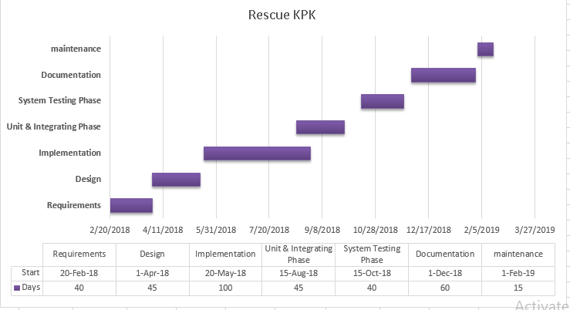

Figure 2.1: Gantt Chart

## 2.8 Risk Management

The Table 2.3 Risk Management Issues shows the number of risks that can occur in our project development**.**

Table 2. 3 provides Activities Risk

Table 2.3 Activities Risk

|  |  |
| --- | --- |
| **Risk** | **Risk and Avoiding Techniques** |
| Urgent Work | If anyone of us become busy in urgent work like marriage ceremony in the family.  **Avoidance**:To start work on the independent milestone.  **Minimizing technique:**The second will take responsibility to do more work to minimize that friend burden of the project. |
| Difficulties in Programming | During implementation sometimes cause difficulties to make a particular module.  **Avoidance:** Take help from online tutorial using the internet or post your question on social communities related the domain.  **Minimizing technique:** Try to make your design as simple as possible and to reduce coupling.  . |
| Getting ill | If anyone of us the project partner becomes seriously ill up to some days.  **Avoidance:** As a single person, not many sicknesses happen.  **Minimizing technique:** One of us must continue the project to avoid delay of the project. |
| Project delay | Risk of project delay that project development run over time.  **Avoidance:** Group members will work on a project on regular basis without delay their development activities.  **Minimizing Technique:** If there is a delay in project schedule extra time will be given to project development than regular time. |
| Team management | The team management is a major issue that creates a bad impact on the project and can cause project delay.  **Avoidance:** For better management every individual to do a task.  **Minimizing technique:** Avoid personal matters during projects work. |
| Error in working  Application | There can occur errors in the working of the application while user uploads a picture text and location.  **Avoidance:** The working of the application system should be made efficient by introducing the try-catch blocks that is try block will be called in case if the requested function is done and if there come any exception in the requested function of the system catch block will be called. And make sure to test it every time a change is made. |
| Mishap with system | Risk of mishap to the system can happen such as crashing of a system.  **Avoidance:** There should be back up of the system at drives.  **Minimizing Technique:** The risk of mishap can be minimized by keeping up-to-date backup versions of the system and using them at the time of risk. |

Scope of this project is very broad in terms of other manually checking yourself. It is an web based software. The scope of this project Any education institution makes use of it providing class schedule, any information they as per their requirement will be stored It can be used in offices and modifications can be easily done according to requirements. There will be a centralized database where all the data of the school can be easily store. User will be able to store their data by just entering it on user interface.School management system is a multiplatform project it comprises of two platforms one is desktop based and the other is web-based. A programming language for web based platform is HTML, CSS, PHP, and for web based ASP.NET which also work for desktop based platforms. It actually deals with converting manual, hectic and slow process of the data to an organized, electronic, fast process by just using mobile phone, tablet or desktop based platforms. Other characteristics are providing accuracy to data by continuously validating data and providing a friendly interface to users. It must be conducted by the Head or Principle of the School or Institution, where the system is taking place. It must be conducted at the same time (simultaneously) School (All Modules). It must involve regular Attempts like attendance, tasks, Announcements at specific time intervals. It must reveal the Strength of a School at a specific period of time. The methodology which has been selected for this project is Iterative model, iterative model will be used for this purpose. Iterative model should be used when the desired system needs to have a lot of interaction with the end users (Students, employees).Iterative ensures that the end users constantly work with the system and provide a feedback which is incorporated in the iterative to result in a usable system. The Table 2.2 will give us the information about the milestone (the expected time duration) to complete the project. Milestone helps us to find out the dependency and non-dependency between modules. It helps us to start work independently for those modules which are not dependent on the other modules. Here briefly defined milestones, Scope os this project which is given in this chart and also the expeccted outputs and we also have defined that how much time will consume for this process and so on.

# Chapter 3

# 3 System Requirements

In this chapter, we will discuss requirements for this project and analysis on potential requirements. Requirement analysis is done to filter out basically what user wants. This phase of the project is important because if it runs smoothly other phases of design and code will go smoothly. If this phase isn’t carried out cautiously not only design and code but requirements too will need exhaustive changes. Well understood software requirements results in efficient development of the system. This project requires a complete understanding of user requirements, functional requirements, and non-functional requirements.

## 3.1 User Requirements

**User requirements are directly gathered from the customers and users.**

Table 3. 1 provides User Requirements

Table 3.1 User Requirements

|  |  |
| --- | --- |
| **UR-1:** | As a user (users), should have a secure registration and login. |
| **UR-2:** | As a user (Admin) have a profile and must changes to users profiles. |
| **UR-3:** | As a user (admin), I want to upload student data. |
| **UR-4:** | As a user (Admin), I want to see all the users record like Student full info , employee information and accounts. |
| **UR-5:** | As a user, I should be able to send notification message |
| **UR-6:** | As a user(student) I must be accessible information. |
| **UR-7:** | As a user i should be able to put organization expenses such as Bills and tax. |
| **UR-8:** | As a user (principle), I should be able to access whole information about student accounts and employee. |
| **UR-9:** | As a user (employee), I should be able see my salary report and month. |
| **UR-10:** | As a user(Teacher) I can put whole student marks record attendance record assignments quizzes etc. |
| **UR-11:** | As a user (principle) I should be able to generate all reports like Transcript, certificate fee printing etc. |
| **UR-12:** | As a user(users) I should be able to change my password. |

## 3.2 Functional Requirements

Functional requirements (FR) are generated for this project by combining user requirements and user conversation with requirement analyst. This part will consider what system will do in the light of user requirements.

## 3.2.1 Conversations Registration

**As a user (users I should have a secure registration and Login.**

The Table 3.1 Login Requirement shows the user conversation to achieve the functional requirement of login as an admin, students, teachers through the Software.

Table 3. 2 provides Login and Registration Requirements

Table 3.2 Login and Registration Requirement

|  |  |
| --- | --- |
| **FR-1** | **Story name:** Secure registration and login as user |
| **Who:** As a user.  **What:** I want to have secure registration through ID and password.  **Why:** To make the application secure and reliable. | |
| **CONVERSATION**  1. User can register if he/she has a valid Registration Id .  2. A user will login with an ID and the password and store during registration process.  3. He can only use SMS if he/she is registered user.  **Successful Login**  1. ID and password must be correct.  **Un-successful Login**  1. Reg ID and Password Wrong(Incorrect User or Password) | |

## 3.2.2 Conversations Profile

**As a user, I should have a profile and can make changes to it.**

The Table 3.3 Profile Requirements shows the user conversation to achieve the functional requirement of user profile through the system.

Table 3. 3 provides Profile Requirement

Table 3.3 Profile Requirement

|  |  |
| --- | --- |
| **FR-2** | **Story name:** User profile |
| **Who:** As a user.  **What:** I want to have a user profile.  **Why:** To see my result, attendance , fee information. | |
| **CONVERSATION**  1. User can access his profile if he has a successful login.  2. A user(Admin) can make changes to his/her profile. | |

## 3.2.3 Conversations Profile Upload

**As a user(admin), I want to upload image post directly from PC.**

The Table 3.4post Upload shows the user conversation to achieve the functional requirement of user post upload through the system.

Table 3. 4 provides profile pic Upload

Table 3.4 Profile upload

|  |  |
| --- | --- |
| **FR-3** | **Story name:** Profile upload |
| **Who:** As a user (admin).  **What:** I want to upload a post through pc.  **Why:** To add to student profile his/her picture. | |
| **CONVERSATION**  1. User can upload profile picture having an image through the software.  2. Users profile will more visible by having his/her profile picture in information. | |

## 3.2.4 Conversation Accessible information.

**As a user (Admin), I want to see whole information about users.**

The Table 3.5 As an admin I want to access and I can see whole information about students , employees, accounts and all these.

Table 3. 5 Conversation users’ information.

Table 3.5 All users’ information.

|  |  |
| --- | --- |
| **FR-4** | **Story name:** All the related information about users. |
| **Who:** As a user (admin).  **What:** I want to see whole information about students, employees, accounts and all these.  **Why:** To check emergency record. | |
| **CONVERSATION**  1. As user info already saved  2. Admin can see all the information of organization. | |

## 3.2.5 Conversations User Notification

**As a user admin, I should be able to send notifications about the Events, result, warning, fee.**

The Table 3.6 user notification shows the user conversation to achieve the functional requirement of sending notification of Events/results and fee.

Table 3. 6 User Notification

Table 3.6 User Notification

|  |  |
| --- | --- |
| **FR-5** | **Story name:** User notification |
| **Who:** As a user.  **What:** I want to be able to send notification to the parents on sms.  **Why:** To send the notification to parents to know about upcoming events or anything. | |
| **CONVERSATION**  1. As admin uploads a post notification should be send to the parents.  2. Parents will be helped to know about activities, event, fee submission and can be any message regard student. | |

## 3.2.6 Conversation Marks Grading

**As a user (Teacher) I want to upload students subjects marks.**

The Table 3.7 Marks grading shows the user conversation to achieve the functional requirement of the user to put student marks to the result.

Table 3. 7 Marks Grading

Table 3.7 Marks Grading

|  |  |
| --- | --- |
| **FR-6** | **Story name:** Marks Grading |
| **Who:** As a user(Teacher).  **What:** I want to upload students subjects marks.  **Why:** To provide exams result to the students. | |
| **CONVERSATION**  1. As students I can see my full subjects marks.  2. principle can upload Transcript result after adding marks by teachers. | |

## 3.2.7 Conversations generate transcript.

**As a user (Admin), I should be able to generate student result transcript.**

The Table 3.8 User data shows the generate transcript conversation to achieve the functional requirement of user data through the system.

Table 3. 8 User Data

Table 3.8 generate transcript

|  |  |
| --- | --- |
| **FR-8** | **Story name:** generate transcript |
| **Who:** As a user(principle).  **What:** I want to be able to upload students result through this system.  **Why:** students will be able to see their result online. | |
| **CONVERSATION**   1. Admin can generate result . 2. Students and parents can access result online. | |

## 3.2.8 Conversations Tax

**As a user (admin), I should be able to store information about Tax like(BISEP TAX, school Tax )**

The Table 3.9 store the tax data conversation to achieve the functional requirement of user through the SMS.

Table 3. 9 TAX

Table 3.9 TAX

|  |  |
| --- | --- |
| **FR-9** | **Story name:** TAX |
| **Who:** As a user.  **What:** I want to be able to store all paid and unpaid tax information to the government.  **Why:** To show tax information in the case of any unpaid claim or something else which we need in emergency. | |
| **CONVERSATION**  1. User can store taxes information. | |

## 3.2.9 Bills

**As a user, I should saw the awareness information about any critical situation like accident, fire and natural disaster which is provide by rescue team.**

The Table 3.10 Bills activity shows the expenses conversation to achieve the functional requirement of organization expenses through the system.

Table 3.10 Bills

Table 3.10 Bills

|  |  |
| --- | --- |
| **FR-10** | **Story name:** Bills |
| **Who:** As a user.  **What:** I want to store my Bills expenses in data base.  **Why:** To calculate and manage expenses. | |
| **CONVERSATION**  1. User can see the whole history about expenses of the bills gas electricity and ptcl.  2. It will help to manage budget of the school. | |

## 3.2.10 Email Notification.

**As a admin I want to send notification about any serious announcement and result etc to the parents and students.**

The Table 3.11 students and parents can receive email from school management through this online system.

Table 3.11 Send Email

|  |  |
| --- | --- |
| **FR-11** | **Story name:** send email |
| **Who:** As a user(Admin).  **What:** I want to send email notification to parents and students through email.  **Why:** To provide them information and any announcement message. | |
| **CONVERSATION**  1. Register users can see the notification which is provide by school managment.  2. Users can take the action when notification sends by sms. | |

## 3.3Non-functional Requirements

### 3.3.1 Performance Requirements

#### 3.3.1.1 User Satisfaction

The system must meet the user expectations.

#### 3.3.1.2 Response Time

The response of all the operation should be at least good.

#### 3.3.1.3 Error Handling

Response to user errors and undesired situations should be taken care of to ensure that the system operates without halting.

#### 3.3.1.4 Safety and Robustness

The system must be able to avoid or tackle disastrous action. In other words, it should be foul proof.

#### 3.3.1.5 User friendly

The system should be easy to learn and understand. A native user can also use the system effectively, without any difficulties.

#### 3.3.1.6 Safety Requirements

System must be able resist any crashes that can occur or any virus attacks.

#### 3.3.1.7 Security Requirements

As this system is totally related to communication system, so user’s privacy and his personal details must be kept secret and secure. All communication record should be kept secret.

### 3.4 User Documentation

#### User Manual

User will be provided with a manual so that he can understand the working and all functionalities of the system. It will contain all necessary details of the system.

## 3.5Assumptions and Dependencies

* Users have internet available in there devices
* Users have register id.
* Users have internet enabled
* Optional components of the project would be implemented only if the time and resources are available.
* The application would be developed using OS architectural model.
* The user will enter valid details.

## 3.6 Overall System Description

### 3.6.1 User characteristics

To help promote students achievement and success, schools must have access to complete, accurate, and timely information about students. One of the benefits of automated SMS is that the student record system will simplify retrieval of required information and is a great instrument for school improvement by taking measures from the information acquired. Despite the use of automated SMS, the government schools in Addis Ababa are using paper based documentation system for performing various tasks and the school administrators apply their knowledge of hit and miss approach in scheduling classes and courses (preparing the timetable) which wastes manpower and much time unnecessarily that does not utilize the current technology

Who needs The SMS SYESTEM:

* School managment.
* students
* parents

So collectively we can say that it is a need of every organization now days.

### 3.6.2 Operating environment

We have selected web as our domain. this system will be operate on desktop and on web system.

**3.7 System constraints**

### 3.7.1 Software constraints

This system is online and offline. It must needed internet connection for students. For admins they can store their information offline as well. Window 10 or later , Xammp server should be needed for administration. Other user can also access it through android and ios or whatever.

### 3.7.2 Hardware constraints

In order to use this system user must have Mobile and Pc. For student to see their information they should have mobile or Pc with internet connection.

### 3.7.3 Cultural constraints.

No cultural constraints.

### 3.7.4 Legal constraints

Legal constraints include many communication related constraints that exist in communication world, and when it will be adopted and implemented in government institutions at that time for sure government approval is required.

### 3.7.5 Environmental constraints

Environment for implementing this system in real life must have a control room(Administration office) in order to update system frequently and save all information of the organization.

### 3.7.6 User constraints

This application is for all age groups so it will be consist of a balanced use of text and GUI. Main functionality will be on one click in order to avoid waste of time.

## 3.8 External Interface Requirements

### 3.8.1 Hardware Interfaces

The following hardware specification will be required during development of such application.

* Processor : 1GHz
* Accelerated emulator : 64-bit OS and Intel processor with support for intelVTx
* Monitor : 1280 X 720 resolution
* RAM : 512MB
* Hard Disk : 2 GB(500MB for IDE+1.5 GB for Android SDK& emu)
* For running this application the following hardware will be required:
* Device : Oprating system
* Minimum space to execute : 10MB

### 3.8.2 Software Interfaces

For developing this application the following Software will be required:

* Operating system : Microsoft windows 10 or later version
* Database : SQL
* Tools : Visual studio, Adobe dream weaver,
* Technologies used : ASP.NET,C# , XML,HTML,CSS,BOOTSTAP.

For running this application the following Software will be required:

* Operating System : windows
* Version : Window 10 or later

# Chapter 4

# 4 System Design

System design is the application of the system requirements to the system development. It specifies the architecture, modules, interfaces, and data of the system in comparison of system requirements. The design includes the logical and physical design of the system.

## 4.1 Use case diagram

Use case diagram shows the behavioral aspect of the system. It depicts the system behavior in terms of user interaction with the system. It demonstrates the user requirements more effectively and helps to clarify the requirements expected of the user. It is the graphical representation of user requirements.

Figure 4. 1 shows the Use Case diagram of the school management system.

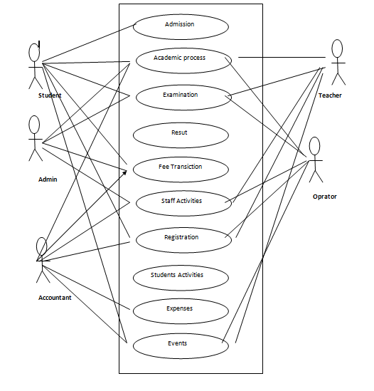

Figure 4.1: Use Case Diagram

## 4.2 Activity Diagram

Activity diagrams are graphical representations of workflows of stepwise activities and actions with support for choice, iteration, and concurrency. In the Unified Modeling Language, activity diagrams are intended to model both computational and organizational processes.

### 4.2.1 Activity diagram for user login

Figure 4. 2 shows the activity diagram of the user login of the SMS.

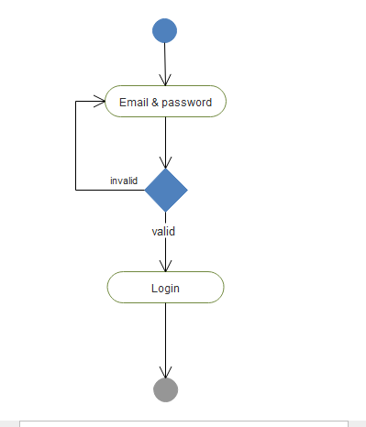

Figure 4.2: Activity Diagram User Login

### 4.2.2 Activity diagram for user Registration

Figure 4. 3 shows the activity diagram of the user Registration of the application.

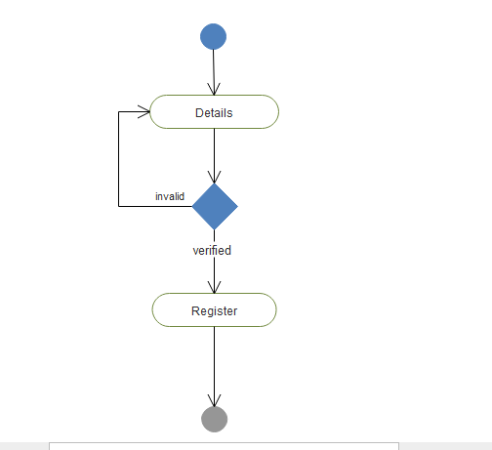

Figure 4.3: Activity Diagram User Register

### 4.2.3 Activity diagram Admin Login

Figure 4. 4 show the activity diagram of push notification.

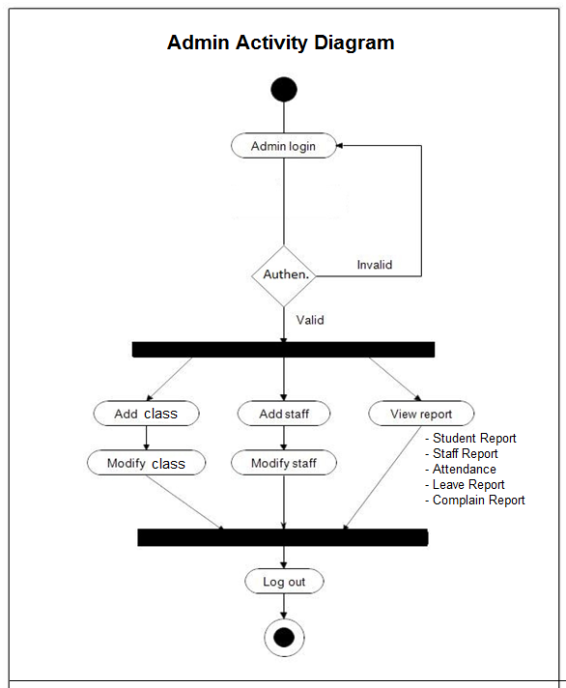

Figure 4.4: Activity Diagram for Admin

### 4.2.4 SMS activity diagram

Figure 4. 5 show the activity diagram for school management .

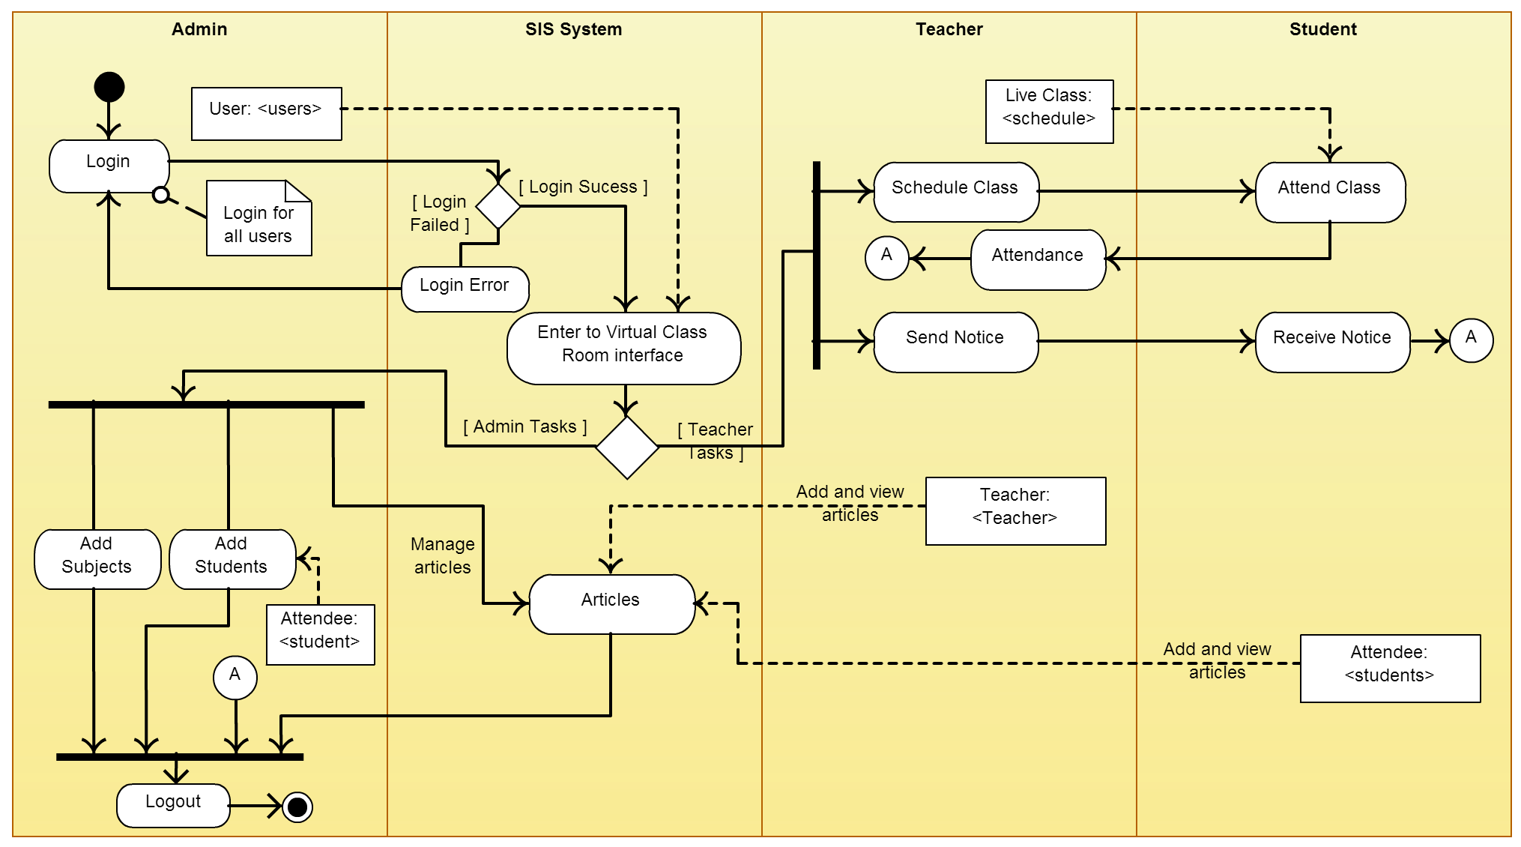

Figure 4.5: Activity Diagram for School Management system.

## 4.3 Sequence Diagram

A sequence diagram shows object interactions arranged in time sequence. It depicts the objects and classes involved in the scenario and the sequence of messages exchanged between the objects needed to carry out the functionality of the scenario. Sequence diagrams are typically associated with use case realizations in the Logical View of the system under development [16].

### 4.3.1 Sequence Diagram for student Registration

Figure 4.6 Student registration Sequence Diagram.

**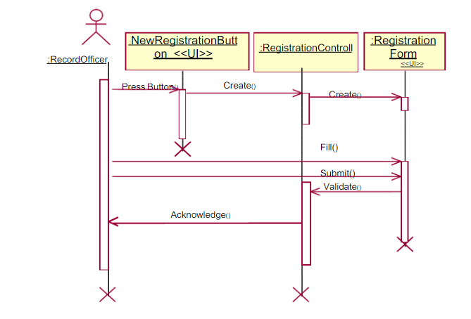**

Figure 4.6: Student Registration Sequence Diagram.

### 4.3.2 Recording attendance Sequence Diagram

### 4.3.3 Attendance Sequence Diagram

Figure 4.7 show Attendance sequence diagram.

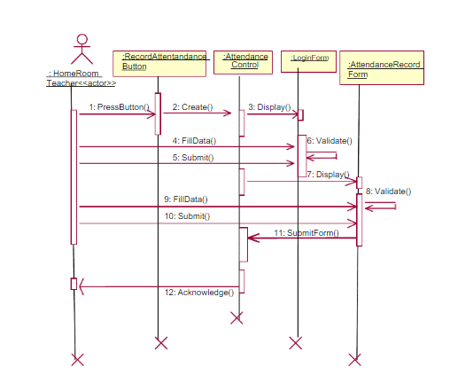

Figure 4.7: Sequence Diagram for Recording Attendance.

Figure 4. 8 Sequence Diagram Generating Transcript.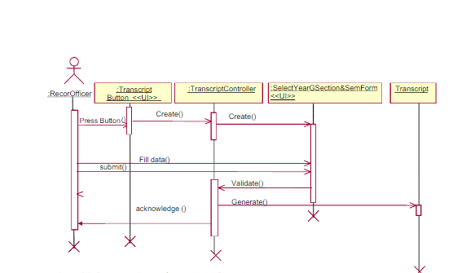

Figure 4.8: Transcript Sequence Diagram

### 4.3.4 Sequence Diagram for viewing student status by the parent.

Figure 4. 9 show Sequence Diagram for viewing student status by the parent.

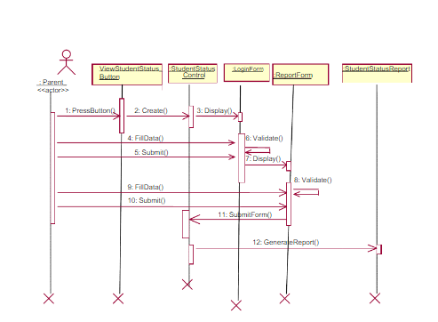

Figure 4.9: Sequence Diagram for viewing student status by the parent

4.3.4 Sequence Diagram for generating Timetable

Figure 4. 10 Sequence Diagram for generating Timetable.

**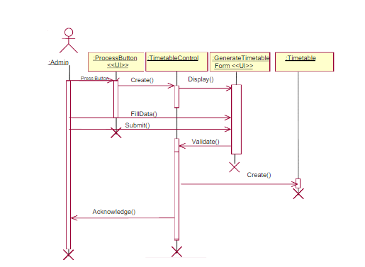**

**Figure 4.10 : Sequence Diagram for generating Timetabl**

## 4.4 Data Flow Diagram

### 4.4.1 Data Flow Diagram level 0

Figure 4.10 shows level 0 of the data flow diagram of the School Management system.

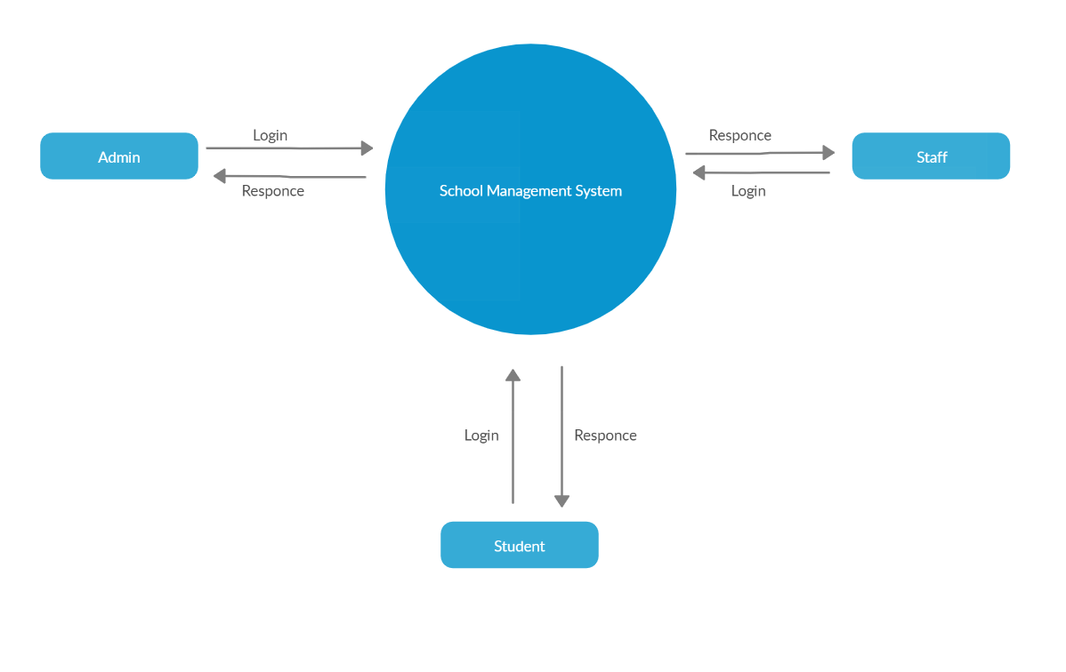

Figure 4.10: DFD Level

### 4.4.2 Data Flow Diagram level 1

Figure 4.11 shows level 1 of the data flow diagram of the School Management system.

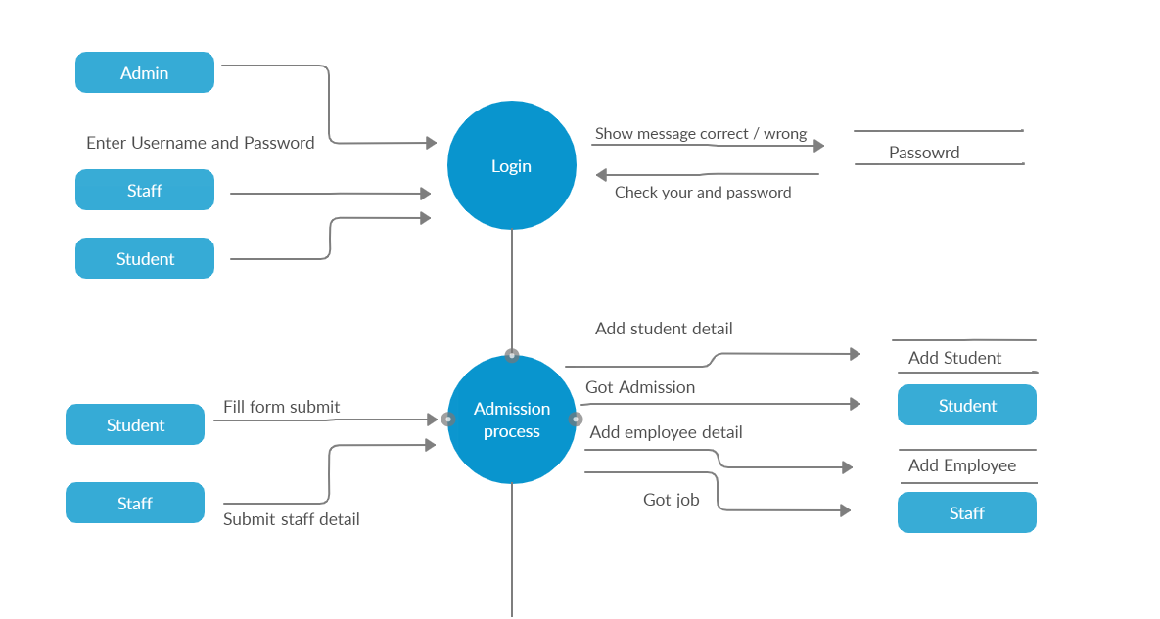

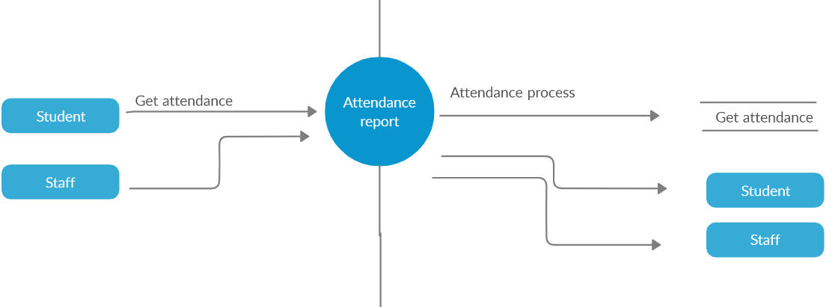

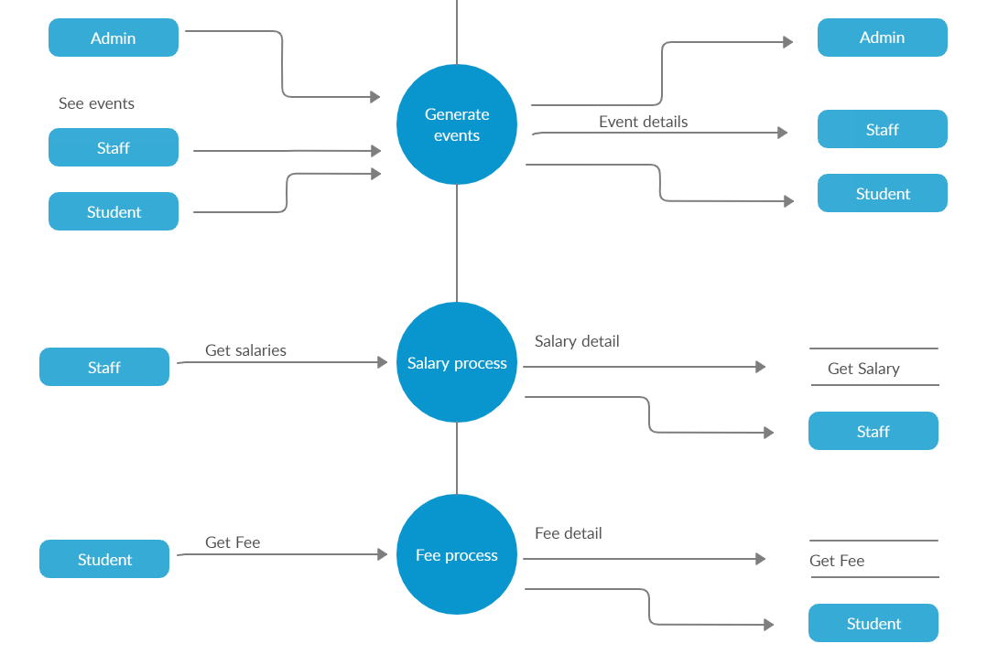

**A**

Figure 4.11: DFD Level 1

### 4.4.3 Data Flow Diagram level 2

Figure 4.12 shows level 2 of the data flow diagram of the School Management system.

**A**

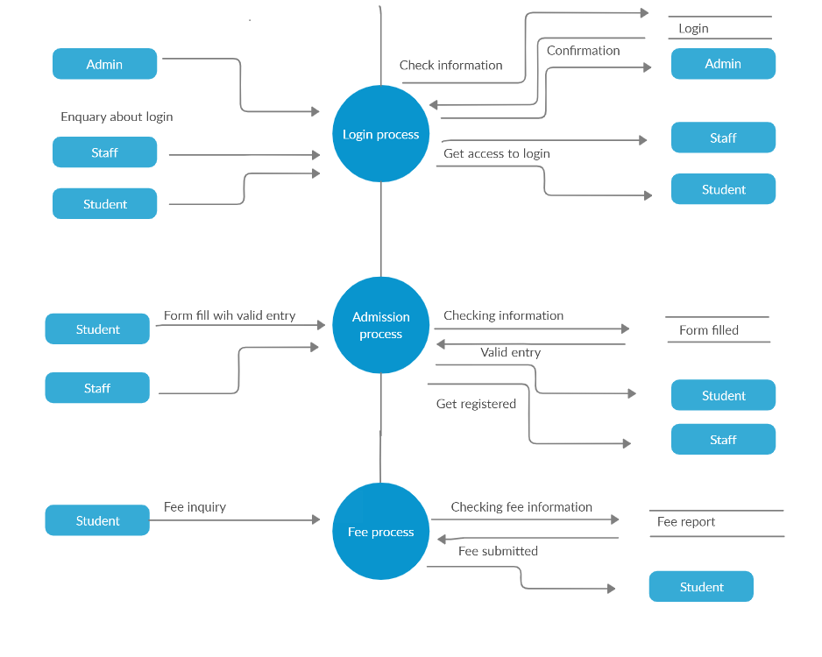

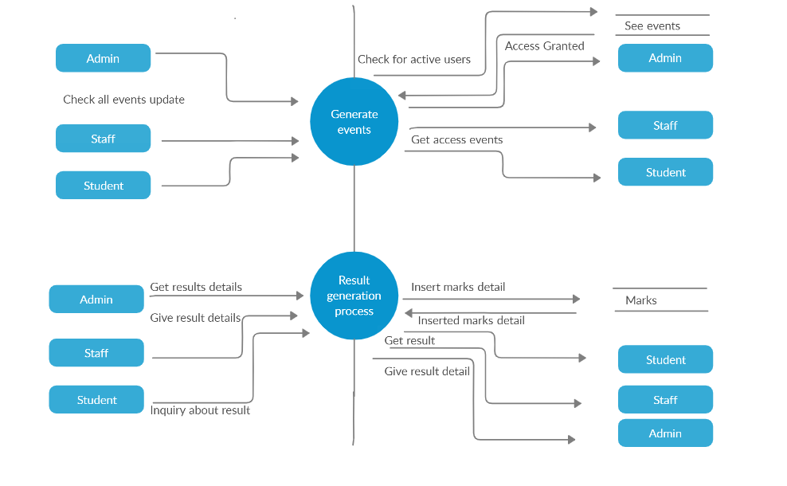

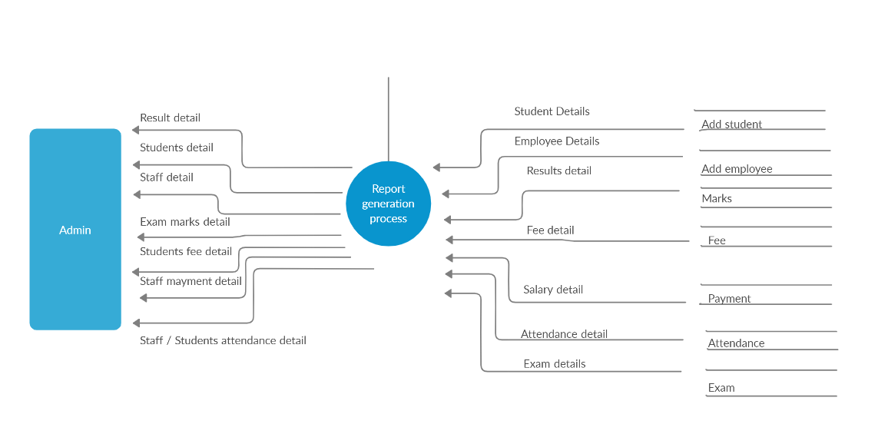

Figure 4.12: DFD Level 2

## 4.5 Entity Relationship Diagram

Figure 4.13 shows Entity Relationship diagram of the School Management system.

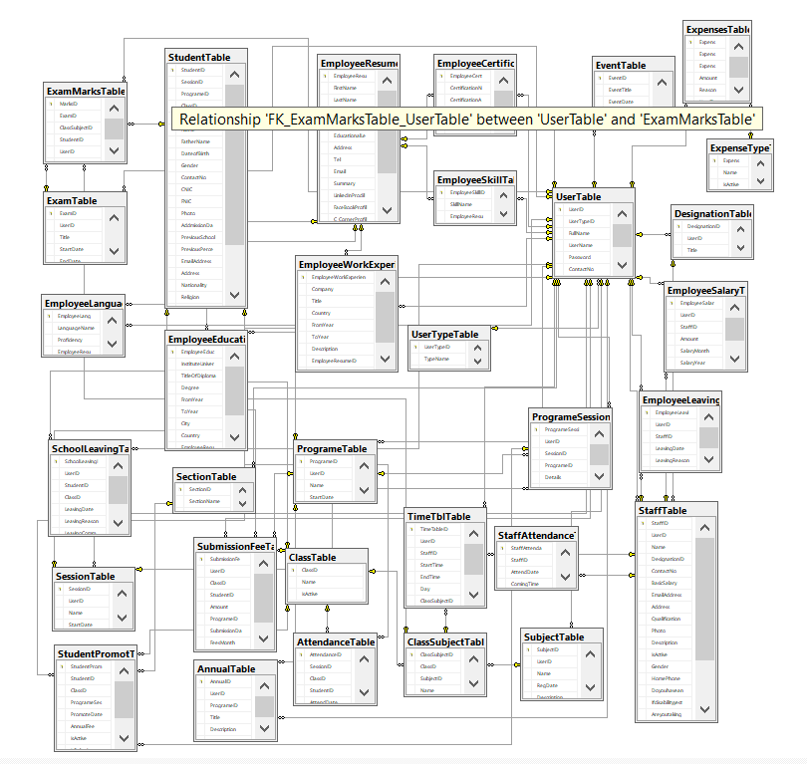

Figure 4.13: ERD

## 4.6 User Interface

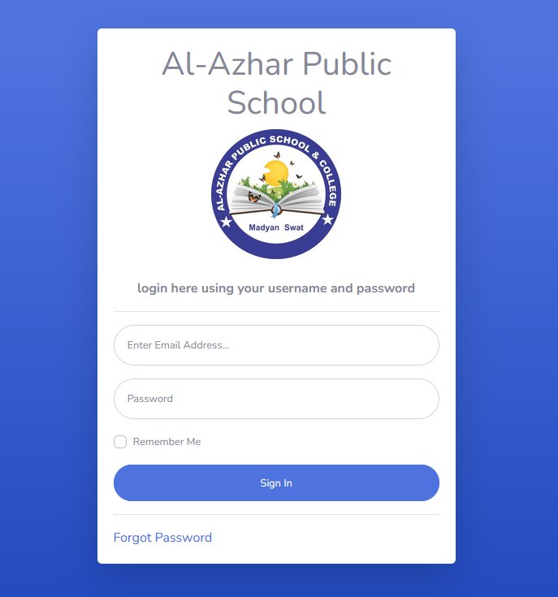Figure 4.13 Login screen of the System.

Figure 4.13 Login Activity

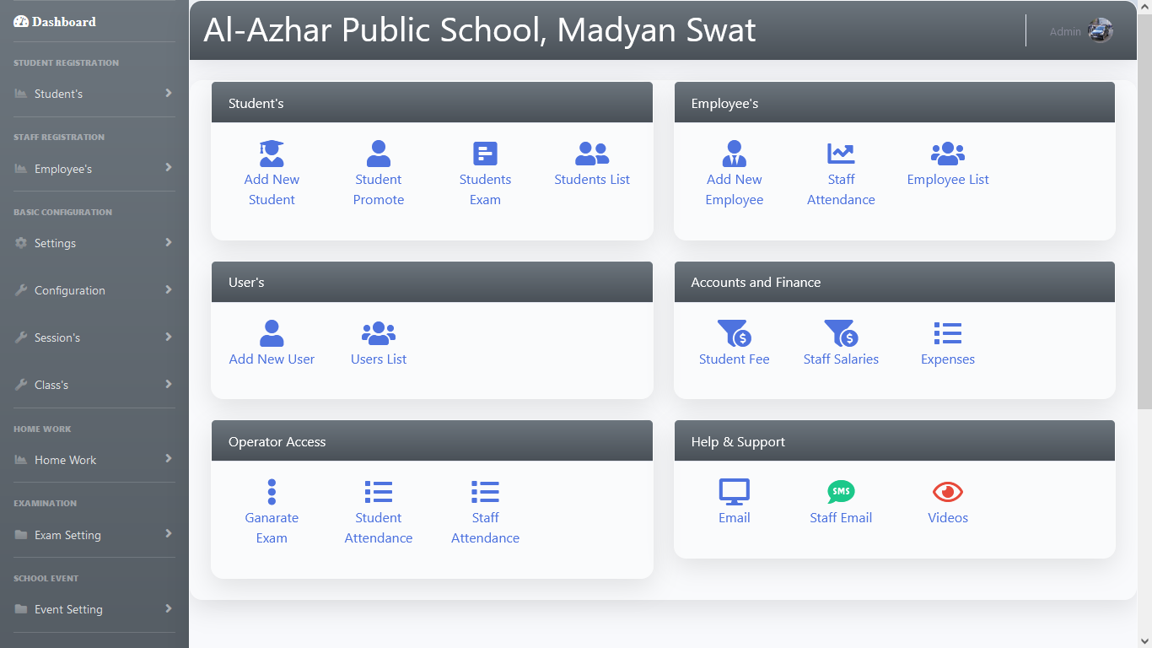Figure 4.14 Main screen of the system

Figure 4.14 Main Screen Activity

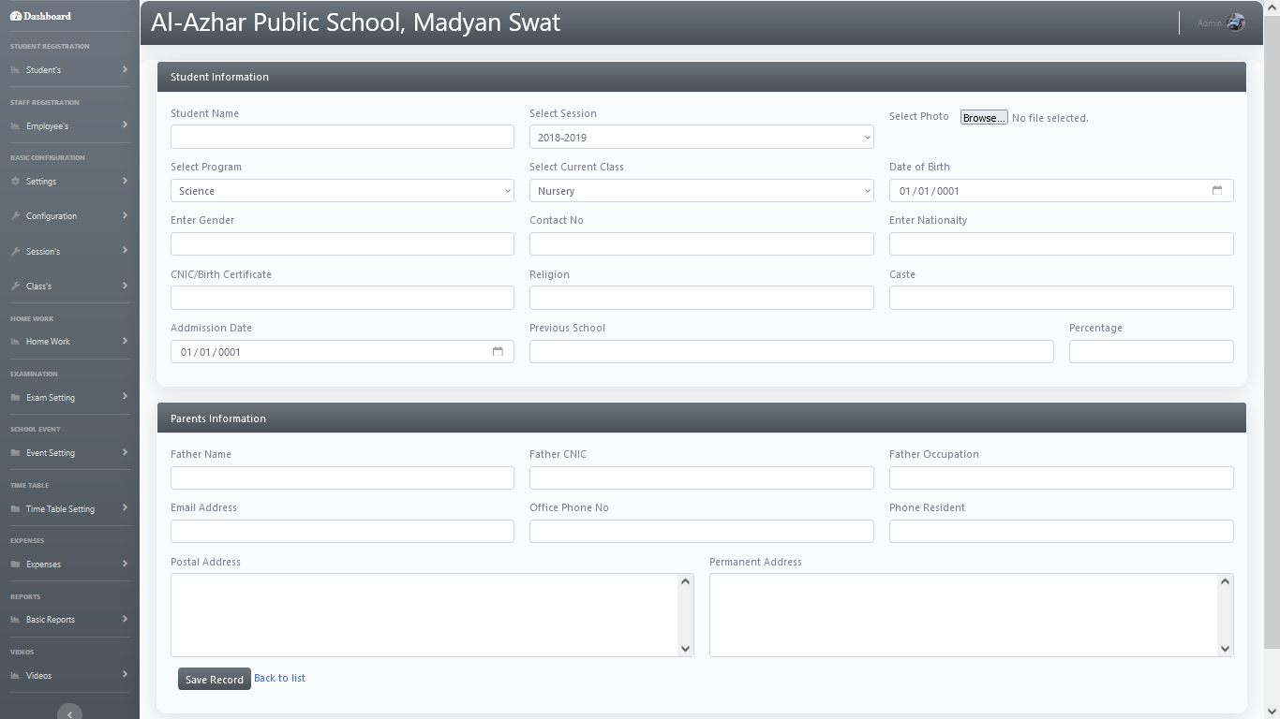Figure 4.15 Student info Activity

Figure 4.15 Student info Activity

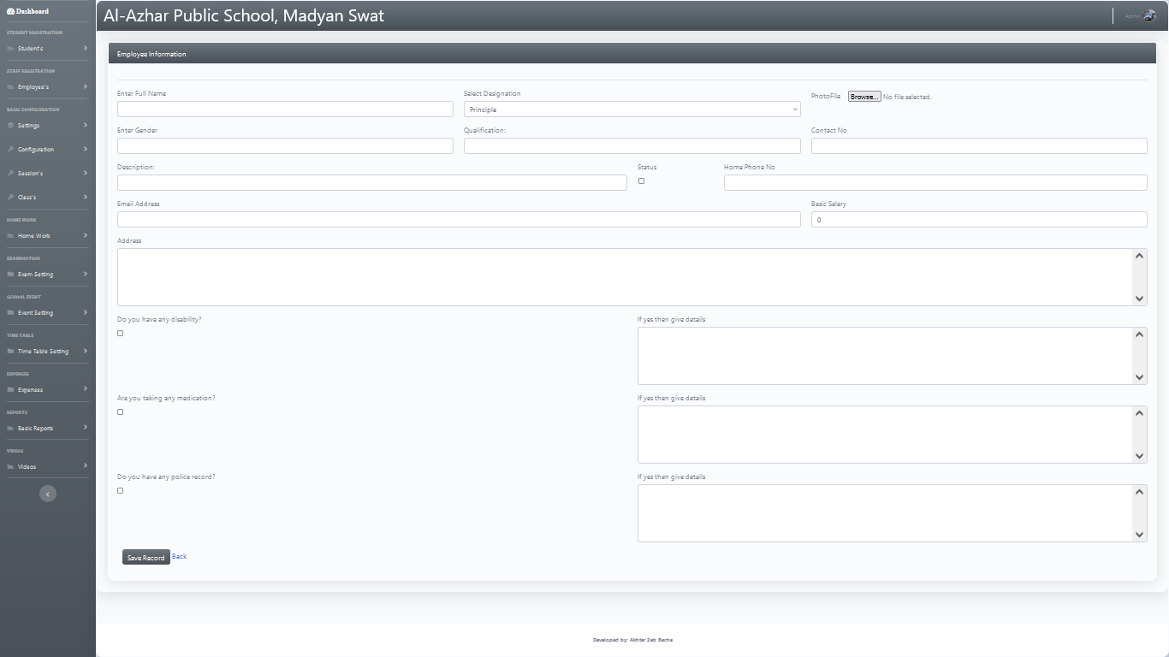Figure 4.16 Employee Info Activity

Figure 4.16 Employee Info Activity

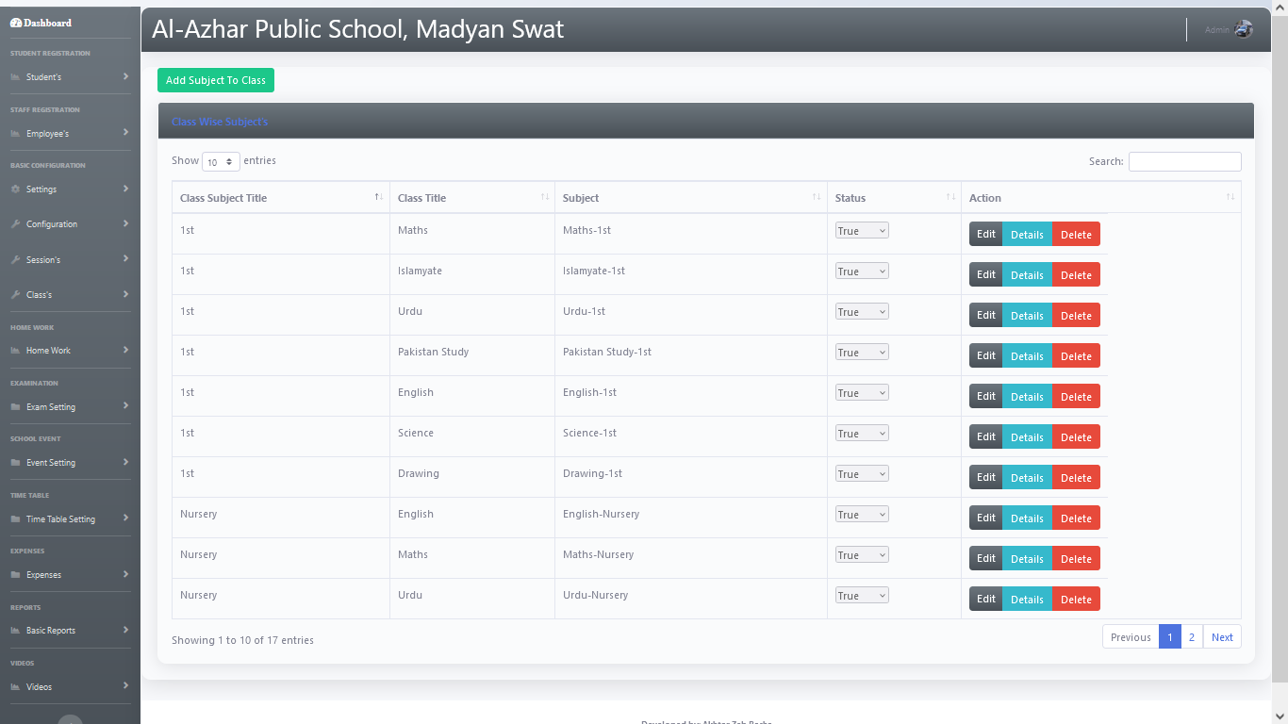Figure 4.17 Add subject to class

Figure 4.17 Add subject Activity

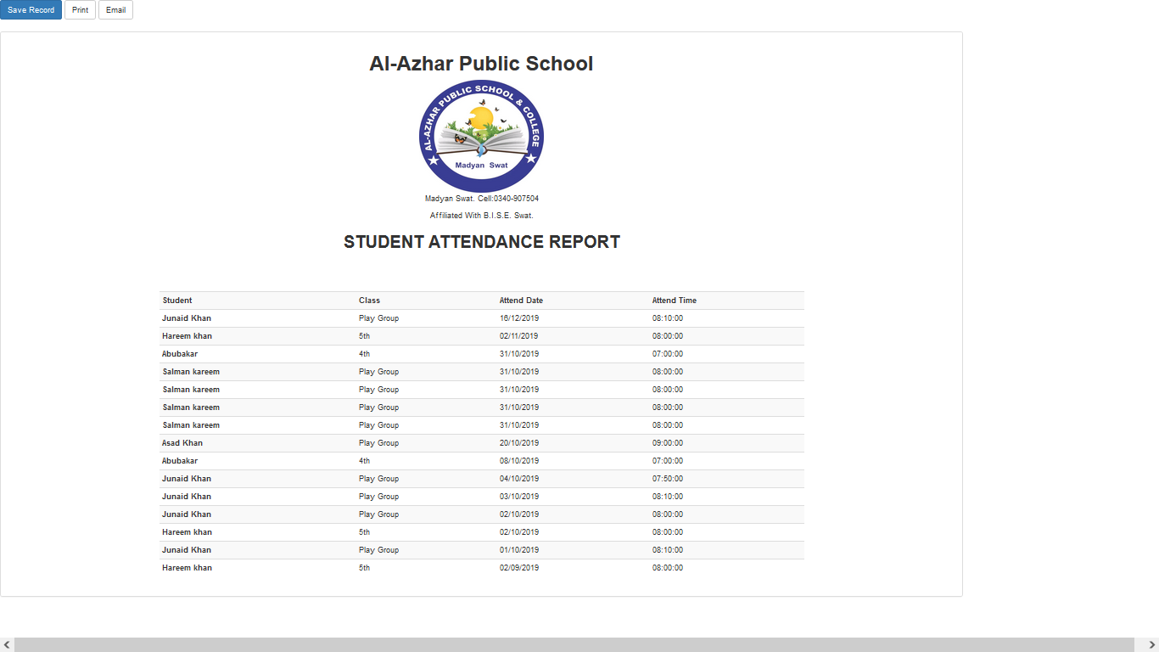Figure 4.18 Certificate Activity

Figure 4.18 Certificate Activity

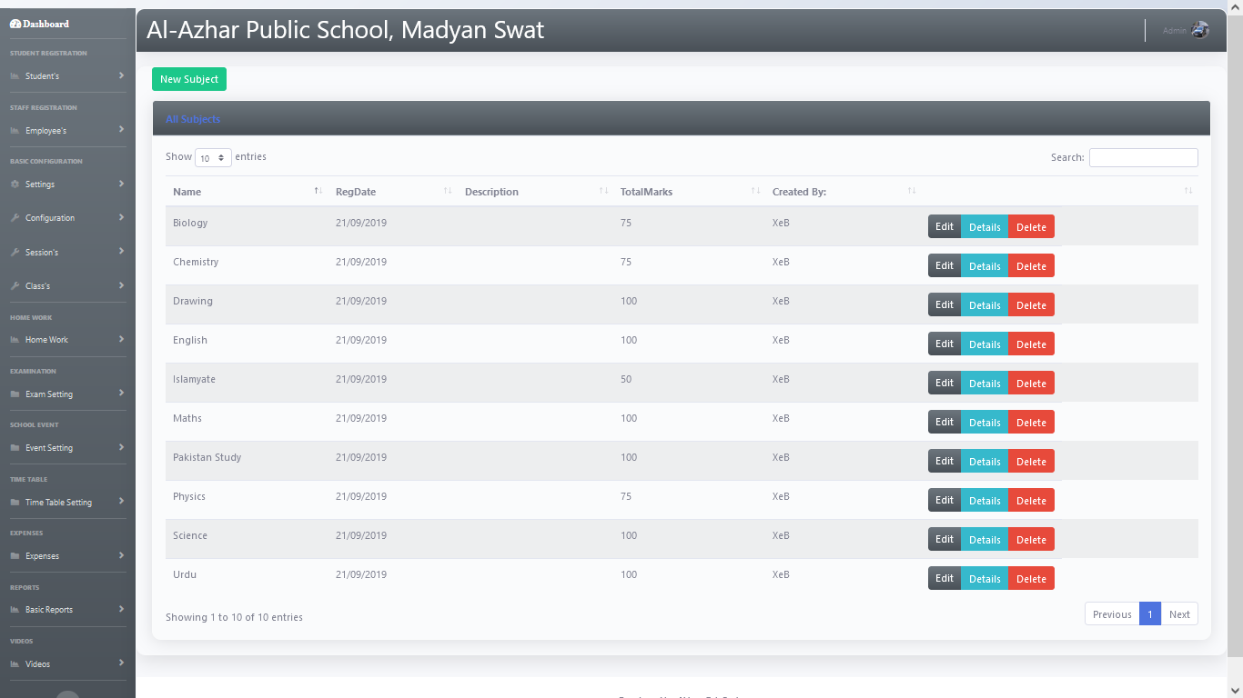Figure 4.19 Add classes

Figure 4.19 Add classes

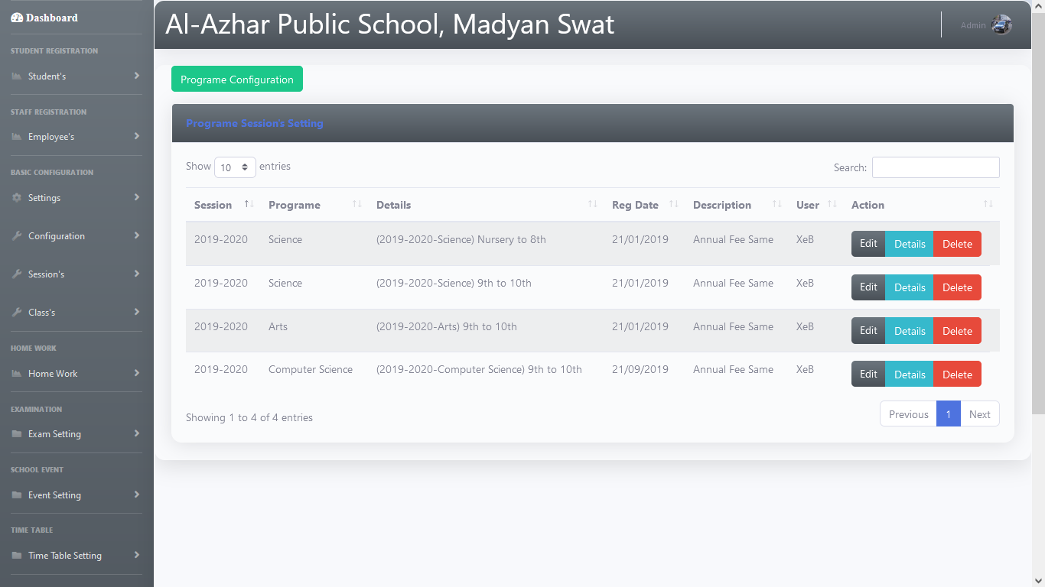Figure 4.20 Program configuration

Figure 4.20 Program configuration Activity

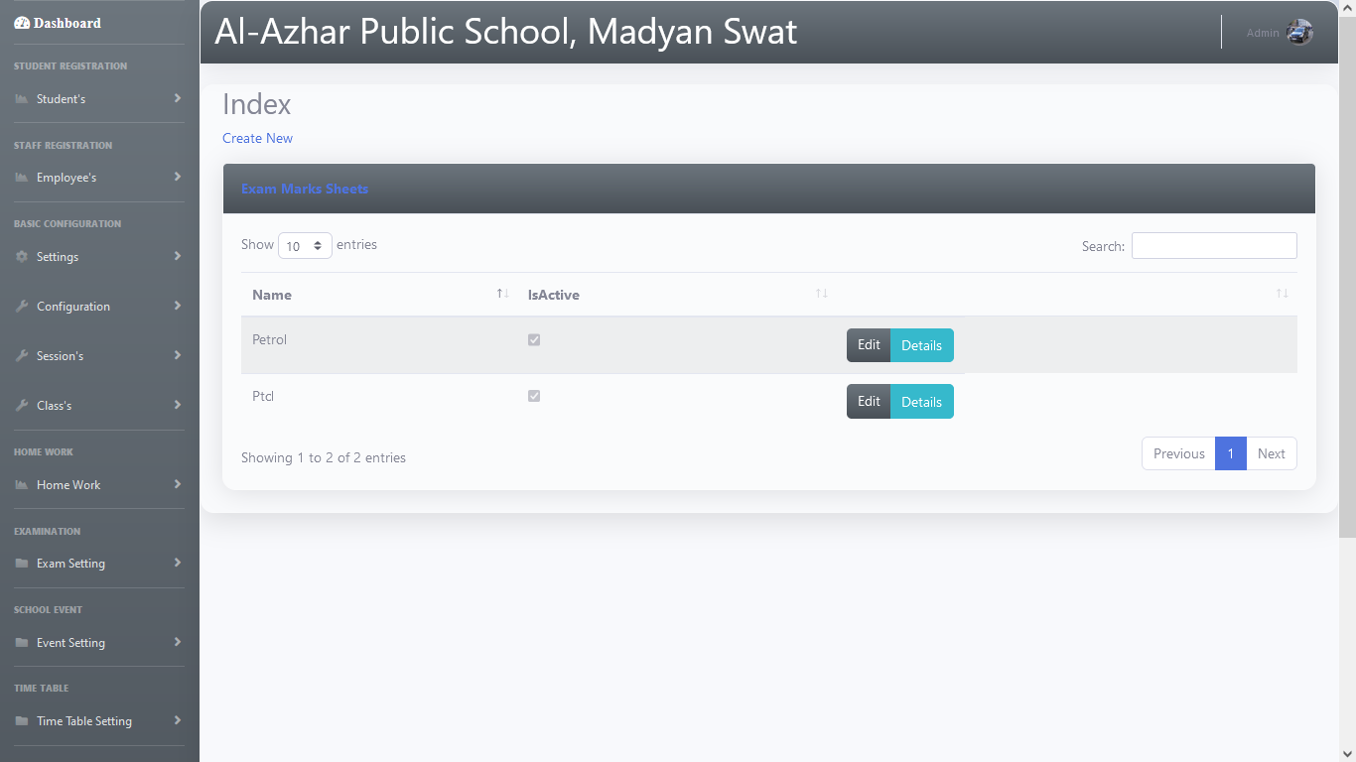Figure 4.21 Expenses

Figure 4.21 Expenses Activity

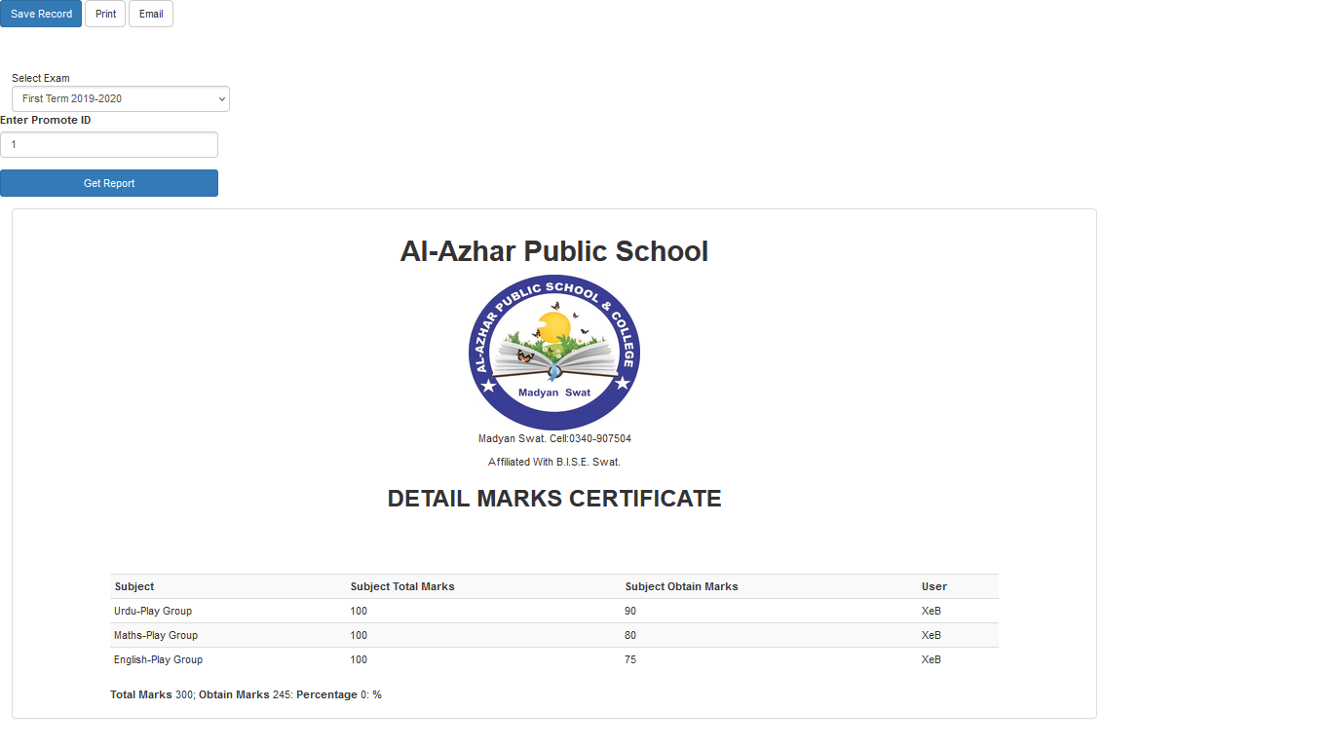Figure 4.22 Transcript activity

Figure 4.22 Transcript Activity

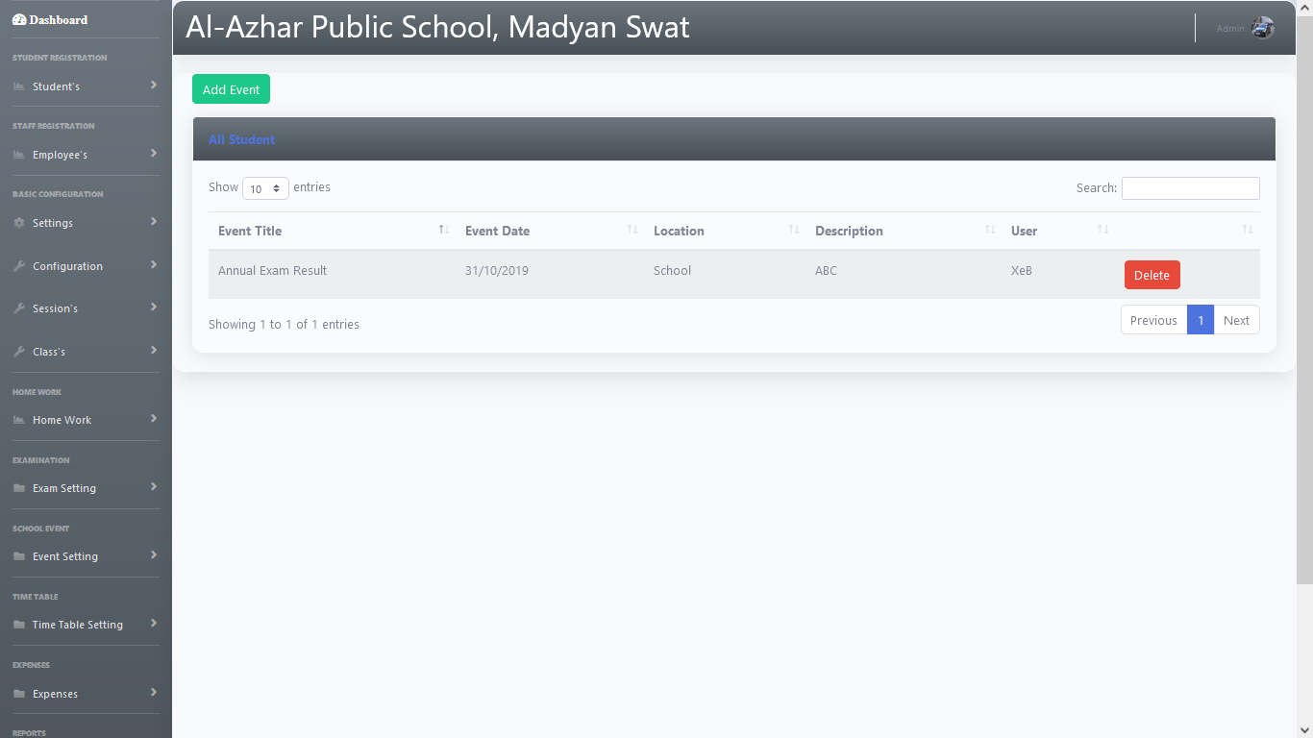Figure 4.23 Events

Figure 4.23 Events Activity

# Chapter 5

# 5 System Testing

System testing is testing of the overall integrated system in order to validate and verify the user requirements. It applies to the working component of the system and occurs after the development of system [13].

## 5.1 Black Box Testing Of System

In Black box testing, the team observed the main functionality excluding the code details and checked that the user, admin and worker login, logout, picture, description and current location send to rescue team and made rout between user and worker push notification is working correctly [14].

### 5.1.1 User Registration

Table 5. 1 shows the test case used to test if sign up is working correctly.

Table 5.1 User Registration

|  |
| --- |
| **Test Case: User Registration** |
| **Data:** Name, CNIC, PhoneNo ,registration number Email, password and designation.  **Developer:** Akhtar Zeb Bacha |
| **Precondition:** Application main page appears |
| **Flow:**  1) Visit the login page.  2) Click to register as a new user.  3) Enter identify information: Name, Email id, Registration  number, Password (twice), upload a picture.  4) Submit the form.  5) Check the email.  6) Login.  **Successful Sign up:**  1) Users enter correct email and password and verify the Email.  **Unsuccessful Sign up:**  1) Users enter incomplete data or did not verify the email. |
| **Post condition:** User set profile page appears. |
| **Test Case Status:** Successful |

### 5.1.2 Admin sign up

Table 5. 2 shows the test case used to test if sign up is working correctly.

Table 5.2 Admin Sign up

|  |
| --- |
| **Test Case: Admin Signup** |
| **Data:** ID, Name, Cnic, email address, address, disable,  **Developer:** Akhtar Zeb Bacha |
| **Precondition:** Application main page appears |
| **Flow:**  1) Admin Start Application.  2) Application main page appears.  3) Admin clicks on sign up.  4) Sign up page appears.  5) Admin signs up for Name, CNIC, PhoneNo, Pin Code,Email, password and designation.  6) Admin clicks the sign-up button and verify email screen appears.  **Successful Sign up:**  1) Admin enter correct email and password and verify the Email.  **Unsuccessful Sign up:**  1) Admin enter incomplete data or did not verify the email. |
| **Post condition:** Admin main page appears. |
| **Test Case Status:** Successful |

### 5.1.3 Employee Registration / sign up

Table 5. 3 shows the test case used to test if sign up is working correctly.

Table 5.3 Employee Registration (Workers) sign up

|  |
| --- |
| **Test Case: Employee Registration (Workers) sign up** |
| **Data:** Name, CNIC, PhoneNo, Department Name,Email, password and designation.  **Developer:** Akhtar Zeb Bacha |
| **Precondition:** Application main page appears |
| **Flow:**  1) Admin Start Application.  2) Application main page appears.  3) Admin clicks on sign up.  4) Sign up page appears.  5) Admin signs up for rescue team (Workers) Name, CNIC, PhoneNo, Department Name,Email, password and designation.  6) Admin clicks the sign-up button and verifies email screen appears.  **Successful Sign up:**  1) Admin enters correct email and password and verify the Email.  **Unsuccessful Sign up:**  1) Administers incomplete data or did not verify the email. |
| **Post condition:** Workers main page appears. |
| **Test Case Status:** Successful |

### 5.1.4 User login

Table 5. 4 shows the test case used to test if login is working correctly.

Table 5.4 User Login

|  |
| --- |
| **Test Case: User Login** |
| **Data:** Email, password and designation.  **Developer:**  Akhtar Zeb Bacha |
| **Precondition:** User registration works correctly |
| **Flow:**  1) User goes to application main page.  2) User clicks on login.  3) The login page appears.  4) User Login with Email and password.  5) User clicks the login button.  6) Homepage appears.  **Successful Login:**  1) Users enter correct email and password and go to Homepage  **Unsuccessful Login:**  1) Users enter incorrect email or password. |
| **Test Case Status:** Successful |
| **Post condition:** Home page appears. |

### 5.1.5 Edit profile

Table 5. 5 shows the test case used to test if Edit profile is working correctly.

Table 5.5 Edit profile

|  |
| --- |
| **Test Case: Edit profile** |
| **Data:** Edit profile Pictures.  **Developer:** Akhtar Zeb Bacha |
| **Precondition:** User login works correctly |
| **Flow:**  1) User(admin) goes to application home page.  2) User(admin) clicks on the settings icon in the top navigation bar.  3) Setting page appears.  4) User clicks on edit profile button.  5) Edit profile page appears.  6) User add new pictures and upload.  **Successful Edit Profile:**  1) Users update the profile and click saves and change saved in the database.  **Unsuccessful Edit Profile:**  1) Users update the profile and click saves and changes do not save in the database.  . |
| **Test Case Status:** Successful |
| **Post condition:** Post uploads successfully. |

### 5.1.6 Bills

Table 5. 6 shows the test case used to test if Accident option is working correctly.

Table 5.6 Bills Option

|  |
| --- |
| **Test Case: Bills Option** |
| **Data:** Bills data of the school provide information about expenses. Electricity , gas , ptcl , other  **Developer:** Akhtar Zeb Bacha |
| **Precondition:** User registration and login works correctly |
| **Flow:**  1) User goes to main page .  2) User clicks on the on the list data.  3) data options will be appear.  4) User click on specific option.  5) User writes description.  6) submit option appear.  7) Click on the submit button.  **Successful Bills Option:**  1) Users click data tlist and add details and click submit button and send data to database  **Unsuccessful Accident Option:**  1) PC problem or different user system haven’t provided complete information about bills/and other information. |
| **Test Case Status:** Successful |
| **Postcondition:**Accidentnotification appears on rescue team (Admin) page. |

### 5.1.7 Tax Option

Table 5. 7 shows the test case used to test if Tax option is working correctly.

Table 5.7 Tax Option

|  |
| --- |
| **Test Case: Tax Option** |
| **Data:** Tax type ,tax year ,amount to pay, data of tax ,paid amount, amount outstanding  **Developer:** Akhtar Zeb Bacha |
| **Precondition:** User registration and login works correctly |
| **Flow:**  1) User goes to main page.  2) User clicks on the on the taxes  3) give description.  4) Tax option appear on main page.  5) full data of tax.  6) principle writes description.  7) Click on the submit button.  **Successful Tax Option:**  1) Users click on tax and add details and click submit button and send data to database.  **Unsuccessful Tax Option:**  1) window problem and for online internet problem haven’t provided complete information about tax data. |
| **Test Case Status:** Successful |
| **Postcondition:**Tax data appears on principle (Admin) page. |

### 5.1.8 Trancript

Table 5. 8 shows the test case used to test if generate Result correctly.

Table 5.8 Trancript

|  |
| --- |
| **Test Case: Trancript** |
| **Data:** Marks , grade , student info , subjects marks.  **Tester:** Wasim Bakhtyar |
| **Precondition:** data upload works correctly |
| **Flow:**  1)Go to main page  2)select class and section  3)select student give grades and marks  4)User(teacher) uploads the data to data base.  **Successful Transcript:**  1) student and parent clicks the map result and it shows complete and accurate result grades.  **Unsuccessful :**   1. Do not show correct and accurate grades marks and result.   **Test Case Status:** Successful |
| **Post condition:** Transcript will be shown as student Result. |

### 5.1.9 Email

Table 5. 9 shows the test case used to test if User Email is working correctly.

Table 5.9 Email

|  |
| --- |
| **Test Case: Notification** |
| **Data:** User post data.  **Actor:** Akhtar Zeb Bacha |
| **Precondition:** Post upload works correctly |
| **Flow:**  1) User goes to Web page.  2) User click system setting.  3) click on student email will be automatically enter in To option.  4) Enter Description message or message .  5) click on send .  **Successful Push Notification:**  1) Users upload the post with description and users send notification to student / parents.  **Unsuccessful Push notification:**  1) Users send email and it does not send. |
| **Test Case Status:** Successful |
| **Post condition:** Email send successfully. |

### 5.1.10 Database.

Table 5. 10 shows the test case used to test if database is working correctly.

Table 5.10 Database.

|  |
| --- |
| **Test Case: Database** |
| **Data:** information send to database.  **Tester:** Akhtar Zeb Bacha |
| **Precondition:** data upload works correctly |
| **Flow:**  1) User uploads the data to database.  2) Admin goes to view data page and post information is appears.  3) Admin clicks on show data.  3) Information page appear.  **Successful Database:**  1) If user click submit button data store in database properly.  **Unsuccessful :**  1) If user click submit and data does not send to database.  **Test Case Status:** Successful |
| **Post condition:** view all data on view marker. |

### 5.1.11 Database Backup

Table 5. 11 shows the test case used to test if lost data can be recover.

Table 5.11 Database Backup.

|  |
| --- |
| **Test Case: Database Backup.** |
| **Data:**  All Data  **Actor:** Akhtar Zeb Bacha |
| **Precondition:** import data to system. |
| **Flow:**  1) User goes to SQL.  2) User clicks on the import database.  3) file generated.  **Successful:**  1) database file Import successfully.  **Unsuccessful :**  1) Does not import data backup file. |
| **Test Case Status:** Successful |
| **Post condition:** Download backup file successfully. |

### 5.1.12 Yearly Tax report.

Table 5.12 shows the test case used to test if admin see the tax report on yearly bases correctly.

Table 5. 12 Admin See The Taxes report on yearly

Table 5.12 Admin See The Taxes report on yearly

|  |
| --- |
| **Test Case: Admin See The Taxes report on yearly** |
| **Data:** Taxes reports.  **Actor:** Akhtar Zeb Bacha |
| **Precondition:** Admin page work correctly. |
| **Flow:**  1) User goes to web (Admin) page.  2) User clicks generate all taxes report .  3) All tax report shows by year.  **Successful:**  1) The tax list page work is correctly.  **Unsuccessful Users and Workers data save:**  1) The tax data list page does not work is correctly. |
| **Test Case Status:** Successful |
| **Post condition:** date save in real time database successfully. |

### 5.1.13 Log out

Table 5. 13 shows the test case used to test if log out is working correctly.

Table 5.13 Log Out

|  |
| --- |
| **Test Case: Log out** |
| **Data:** User must be logged in  **Developer:** Akhtar Zeb Bacha |
| **Precondition:** User logs works correctly |
| **Flow:**  1) User logged in.  2) User clicks on the log out icon in the top navigation bar.  3) User clicks on log out.  5) Confirmation dialogue box appears  .  **Successful Log Out:**  1) User clicks the logout button and successfully log out of the application.  **Unsuccessful Log Out:**  1) User clicks the logout button and does not successfully log out of the application. |
| **Test Case Status:** Successful |
| **Post condition:** User log out successfully and the main page appears. |

# Chapter 6

# 6 Conclusion

In this project, we developed an automated school management system that facilitates the various activities taking place at schools. The system developed in the project consists of windows and web applications. These are two different applications on the same database. The windows application takes most of the activities such as offline student registering, transcript and report card generation and producing the timetable. The web application facilitates attendance recording by the homeroom teachers and to view reports, to view status of students by students, teachers and parents. Our solution of the timetabling problem is very simple. Data structures are used to implement the timetable designed. The scheduler selects a subject-teacher from the database, retrieves all the classes assigned to the teacher, calculates the load of the teacher which cannot be greater than the maximum load and selects one of the days randomly based on the number of lessons of the subject, searches a free appropriate time slot and assigns the slot to the lesson. The scheduler repeats the process until the load of the teacher becomes zero and all the teachers in the database are visited. Finally the result generated is stored in a database. The prototype has been tested with data from Dawn Cambridge high School. It has been shown that the system effectively registers students along with parental information, easily retrieves information about a student and generates the required reports such as transcript, report card and timetable. In addition to generating a feasible master timetable it produces a time table for each teacher. Furthermore it has been shown that the web application of the system helps attendance recording by the homeroom teacher and parents can view the status of their children using the Internet or Intranet of the school.

# Chapter 7

# 7 References

[1] Nikola B., "A WEB-BASED SCHOOL MANAGEMENT SYSTEM", The IASTED International Conference on Computers ad Advanced Technology in Education and the IASTED International Symposium on Web-Based Education, 2009.1.

[2] Young C. Park, "Study of e-learning ad ICT Education in Korea", 12th World Multi-Confernece on Systemics Cybernetics ad Informatics (WMSCI 2008) Joint with the 14th International Conference on Information Systems Analysis ad Synthesis (ISAS), 2008

[3] Fu Lianxu, Luo Fei, Wen Shaochun, The Mis Design Based Web Users' Securicy, Computer Application, 2001.

[4] Discretionary Access Control Issues in High Assurance Secure Daabase Management Systems[R]", NCSC Technical, vol. 5, no. 5, May 1996

[5] Young C. Park, "Study of e-learning ad ICT Education in Korea", 12th World Multi-Confernece on Systemics Cybernetics ad Informatics (WMSCI 2008) Joint with the 14th International Conference on Information Systems Analysis ad Synthesis (ISAS), 2008.1.

[6] Nikola B. Serbedzija, "A WEB-BASED SCHOOL MANAGEMENT SYSTEM", The IASTED International Conference on Computers ad Advanced Technology in Education and the IASTED Internationa Symposium on Web-Based Education, 2003.1.

[7] M Mifsud, J. (2018). Requirements Gathering For Better User Experience Pt1 - Usability Geek. [online] Usability Geek. Available at: http://usabilitygeek.com/requirements-gathering-user-experience-pt1/ [Accessed 14 Jul. 2018.

[8] M Mifsud, J. (2018). Requirements Gathering For Better User Experience Pt1 - Usability Geek. [online] Usability Geek. Available at: http://usabilitygeek.com/requirements-gathering-user-experience-pt1/ [Accessed 14 Jul. 2018].

[9] Eriksson, U. (2018). What are Non-Functional Requirements?. [online] ReQtest. Available at: http://reqtest.com/requirements-blog/what-are-non-functional-requirements/ [Accessed 21 Jul. 2018].

46

[10] https://books.google.com.pk/books?id=PkVy\_zAaruMC&pg=PT120&lpg=PT120&dq=system+design+classification+in+logical+and+physical+design [Accessed 18 Nov. 2018].

[11] https://www.smartdraw.com/data-flow-diagram/, Accessed on November 9,2017.

[12] URL:http://softwaretestingfundamentals.com/system-testing/, Accessed on November 10,2017.

[13] Softwaretestinghelp.com. (2018). What is black box testing? Black box testing types and techniques—Software TestingHelp. [online] Available at: http://www.softwaretestinghelp.com/black-box-testing/ [Accessed 8 Aug. 2018].

[14] En.wikipedia.org. (2018). Activity diagram. [online] Available at: https://en.wikipedia.org/wiki/Activity\_diagram [Accessed 18 Nov. 2018].

[15] Archivist Pakistan. (2019). *School SMS Software and Text Messaging System*. [online] Available at: https://www.archivistonline.pk/communicator/ [Accessed 14 Oct. 2019].